DIGIT 303 DEC

k k k k k k k k k k k k k k ft ft

BRECK H CAMP CML P0 BOX 47070 ATLANTA GA 30362

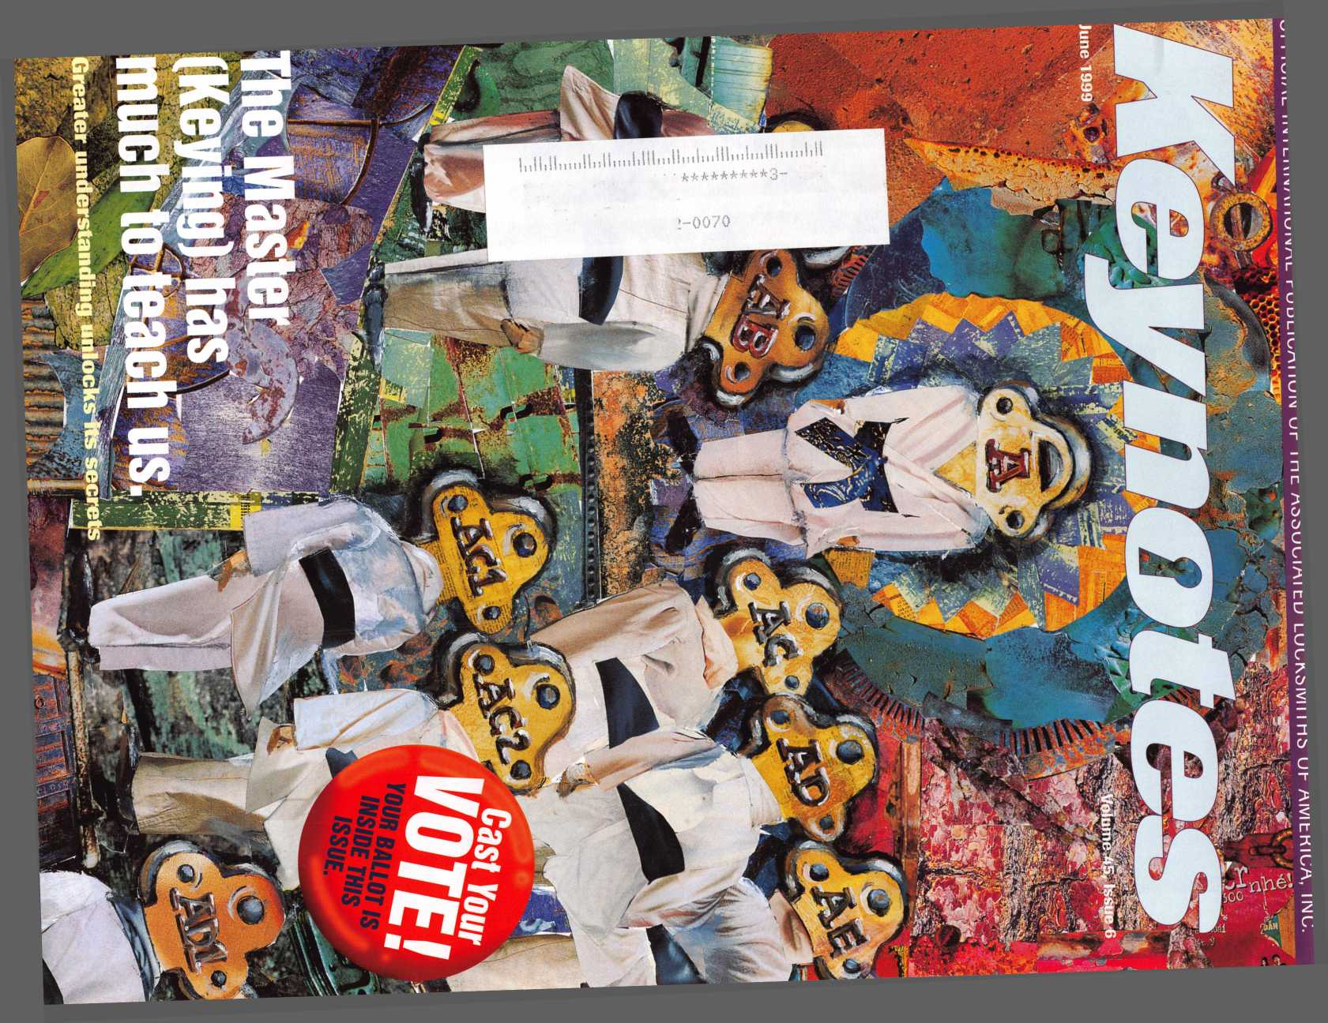

Dedicated to Excellence  
Expert Direction

Knowledge of Codes and Standards  
Technical Expertise  
Professionalism  
Experienced Advice  
An Industry Resource

*fmi mi*

S $ -expires, * S

m i#i

To be certified as an Architectural Hardware Consultant (AHC) or Certified Door Consultant (CDC), individuals must dedicate many years to the architectural openings industry. Their knowledge of the total openings industry within the commercial construction arena is unparalleled, giving them an edge over the competition. Use of the official Seal signifies the consultant as being required to maintain his or her knowledge through continuing professional education. Look for this Seal on hardware schedules, door schedules and drawings, letters and other documents. It indicates commitment, expertise and quality.

Demand this

.Itihn Dm;. IIIIC

in ifi

* \ c

x 1 /

w

\S""'



For a copy of a brochure listing consultants in your area, contact the Door and Hardware Institute, 14170 Newbrook Dr., Suite 200, Chantilly, VA 20151-2232; 703/222-2010; fax 703/222-2410; e-mail [techdept@dhi.org](mailto:techdept@dhi.org); or access the information through the Institute's website: [www.dhi.org](http://www.dhi.org).

m



We've Unlocked the Secret to Selling Safes!

**r Introducing Meilink's New Sales Promotion Program.**

Secure more sales and increase profits

with Meilink’s sales promotion program, the

safe industry’s first comprehensive dealer

marketing package. It starts with a Meilink

exclusive. A fire and burglary rating system that

simplifies comparison shopping for consumers

Meilink follows through with promotional

materials, attractive displays, and other

persuasive marketing tools that practically

push Meilink safes into your customer’s hands

Put Meilink’s marketing power to work and

watch our complete line of composite, plate,

and cash-handling safes leap to the top of

your best-seller list

**For more information contact Grant Hart at**

**1-800-MEILINK**

**111 Security Parkway**

**New Albany, IN 47150**

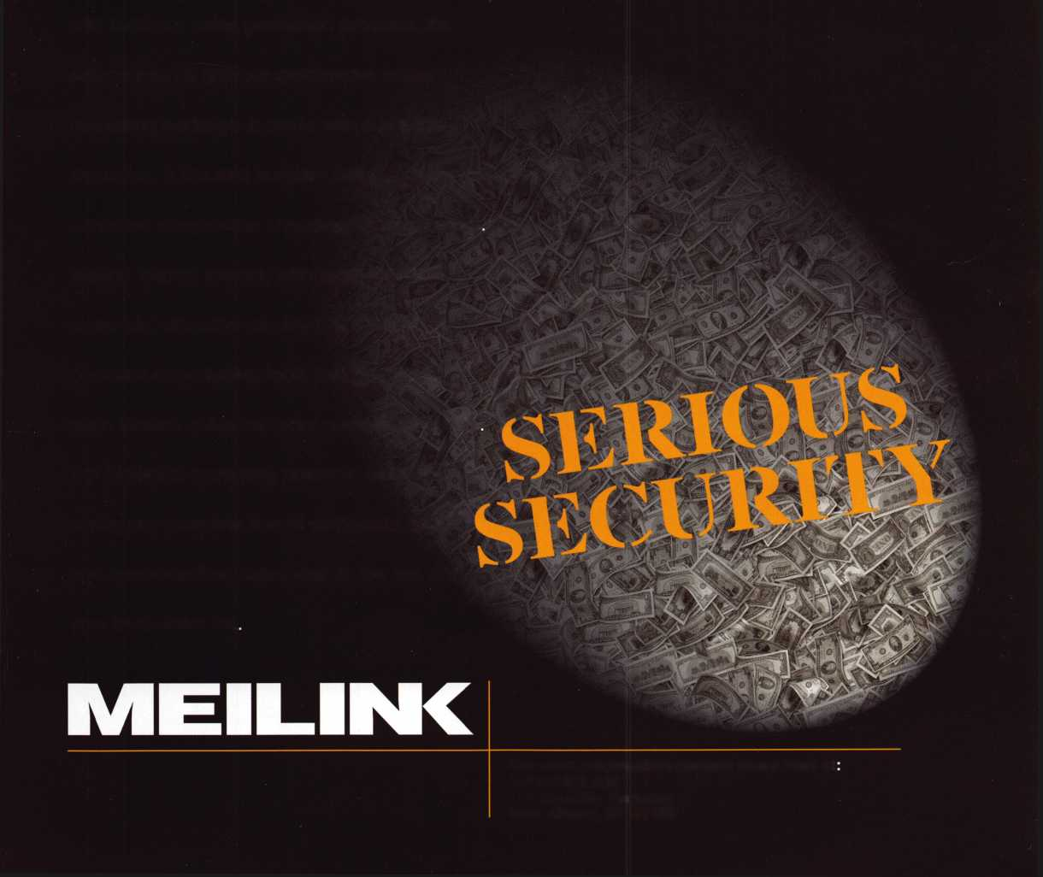

Contents

Features

4

President’s Journey

**June**



14

Breaking In To An Existing Master Key System

Not an easy task, but one that pops up when you least expect it. Be prepared with these helpful tips.

By Billy B. Edwards Jr., CML

16

The Locksmith’s Liability

You’ve finally conquered the procedure of Master Keying, but are you familiar with Cryptology? You will be after reading this insightful article.

By Don Dennis, CPL

19

Holding A Successful Keying Conference.

often painstaking process is discussed in-depth

by one of Master Keying’s true ‘masters.’

By Jerome V. Andrews, CML

22

ALOA *99 Election

Candidate profiles, important information and a ballot for easy return! Have you voted?

24

Master Keying Software from Data Logic

A relief from number crunching? A faster way of Master Keying? Learn more about this new software and what it can offer you.

By Sal Dulcamara, CML

26



10

Security Marketplace

13

Applicants

Scheduled for clearance June 1

**Volume 45, issue 6**

**Departments**

7

Core

A car thief tries to fool a locksmith! Plus, new websites to check out!

8

Upcoming Events

43

Authors in this Issue

Have you voted for Author of the Year?

44

Backpage

Another Cincinnati mind-bender.

Send in your answers for a special prize!

Edi-Lock

A multi-purpose computer program that will make running your business easier than ever.

By Poul Dyson

The Cover:

Methods, management and mastery of the Master Keying process are explored throughout this issue.

Cover illustration ©Isabel Martinez

28

Bringing Ghost (Keys) to Life

Boo! Hey, don’t be afraid. Our author explores the concept of ghost keys with plenty of charts and detailed explanations.

By Greg Perry CML, CPS

33

Locksmith Librarian

A new feature! Our resident librarian reviews The Complete Book of Locks and Locksmithing.

By Michael A. Ferrill

Art direction Valerie Rowe

Graphic design Lori Brennan

40

Legislative Update

Get a preview of what to expect at the ALOA Legislative Booth at ALOA ’99- Plus, legal goings on around the country.

By Tim McMullen

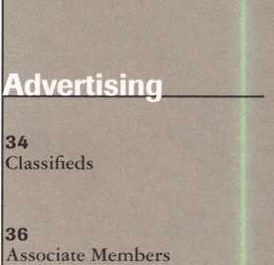

39

Ad Index

:

■SI



June 1999

Keynotes

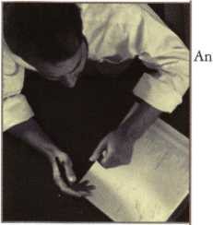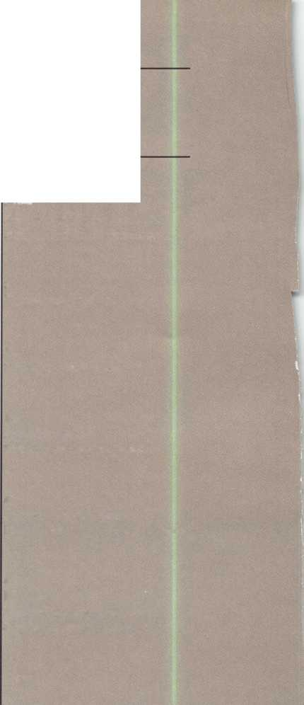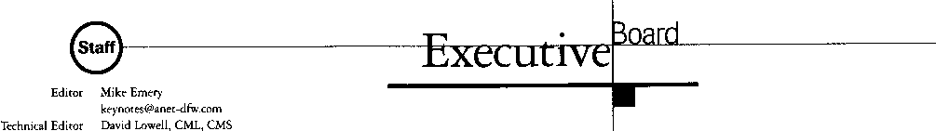

Communications Coordinator Editorial Advisor

Advertising Sales

Contributing Editors

Contributing Authors

[david@aloa.ioffice.com](mailto:david@aloa.ioffice.com)

Patanya Johnson

John D. Cannon, CML

[jdcannon@worldnet.att.net](mailto:jdcannon@worldnet.att.net)

Marvin Diamond

Native American Journal Co.

(770) 998-7056

[thediamonds@mindspring.com](mailto:thediamonds@mindspring.com)

Paul Chandler, CRL

Claire Cohen, CML

Sal Dulcamara, CML

Jerome V. Andrews, CML

Brian Costley, CML, CMS

Bob De Weese, CPL

Ray D’Adamo, CML

Michael A. Ferrill

James Glazier, CML

Daniel Graffeo, CRL, CMS

Wayne Gurnee, CRL

A.J. Hoffman, CML

Ken Holmlund, CRL

Ray Lusk, CML

Mark Ohno

Randy Simpson, CML

Robert Stafford, CPL

Dave Thielen, CML

Grand Master Key Sponsors of the ALOA ’99 Convention and Security Expo:

medeco Medeco Security Locks

HIGH SECURITY LOCKS

MEILINK Meilink

Additional contact information for the ALOA Board and most Keynotes authors are available through “Locksmith Search’” on the ALOA website- [www.aloa.org](http://www.aloa.org) or by contacting the ALOA office at 3003 Live Oak Street; Dallas, TX 75204; (800)532-2562; FAX (214)827-1810; e-mail [aloa@aloa.org](mailto:aloa@aloa.org).

ALOA Professional Staff

Executive Director

Operations Manager

Receptionist  
Mail Room Coordinator  
Comptroller  
Finance Coordinator  
Meetings Manager

Meetings Coordinator  
Government Affairs Manager

PRP/Education Manager

PRP/Education Coordinator

Charles W. Gibson, Jr., CAE  
[charlie@aloa.ioffice.com](mailto:charlie@aloa.ioffice.com)  
Mary May

mary @aloa. ioffice.com  
Heather Reynolds  
Jeff Jordan  
Kathy J. Romo  
Janelle Vergara  
Jessica Smith  
[jessica@aloa.ioffice.com](mailto:jessica@aloa.ioffice.com)  
Janelle Vergara  
Tim McMullen  
[tim@aloa.ioffice.com](mailto:tim@aloa.ioffice.com)  
David Lowell, CML, CMS  
[david@aloa.ioffice.com](mailto:david@aloa.ioffice.com)  
Ashley Spencer

|  |  |
| --- | --- |
| Membership Manager Brandon Durrett |  |
| [brandon@aloa.ioffice.com](mailto:brandon@aloa.ioffice.com) |  |
| Membership Coordinator Jackie Arnett | ULlAI |
| [jackie@aloa.ioffice.com](mailto:jackie@aloa.ioffice.com) |  |
| Chapters & Regional |  |
| Associations Liaison Tim McMullen |  |
| [tim@aloa.ioffice.com](mailto:tim@aloa.ioffice.com) |  |

President

Dallas C. Brooks (334) 826-8990

Secretary

John D. Cannon, CML (703) 960-6413

Directors, Northeast

James H. Glazier, CML (301) 831-5454 John C. Magee, III

1. 845-3434 William L. Young, CML
2. ) 647-5042

Directors, Southeast

Jeffreys. Nunberg, CML, CMS (305) 324-8800 Donald E. Rul6, CML (601) 324-2658

Directors, North Central

Mark E. Blum, CML, CPS (517) 482-5809 John J. Greenan, CML, CPS (773) 486-2030

Director, South Central

Randy L. Simpson, CML (713) 780-7026

Directors, Southwest

Gordon Racine, CML (719) 384-4707 John I. Shandy, CML (303) 774-9791

Director, Northwest

Scott Henke, CRL, CPS (907) 248-3785

Director, Associate Members

Judd Penske (800) 634-5465

Non-voting Directors

Jerome V. Andrews, CML (216) 642-3900 Steve G. Engel, CML, CPP (920) 731-5400

Trustees

David M. Lowell,CML, CMS (800) 532-2562 Breck H. Camp, CML (770) 455-6244 Henry H. Printz, CML (973) 538-2737 Leonard J. Passarello, CPL (416) 752-7210

Mission Statement: The Associated Locksmiths of America, Inc. is dedicated to enhancing the professionalism, education and ethics among locksmiths and those in related sectors of the physical security industry. With approximately 10,000 members in the United States, Canada and the freeworld, ALOA is poised to help members obtain the knowledge, the strength, and the confidence to perform their role in the physical security field with pride and dignity. But it is only through active involvement and participation that ALOA can fully achieve its potential-and can help members to achieve theirs.

Policies: Keynoted is the official publication of the Associated Locksmiths of America, Inc. (ALOA). Keynoted acts as a moderator without approving, disapproving, or guaranteeing the validity or accuracy of any data, claim, or opinion appearing under a byline or obtained or quoted from an acknowledged source. The opinions expressed by the authors do not necessarily reflect the official views of ALOA. Also, appearance of advertisements and new products or service information does not constitute an endorsement of products or services featured by the Association. The Association does not accept responsibility for the inaccuracy of any data, claim, or opinion appearing in this publication, due to typographical errors on the part of the authors, Association staff or its agents. Editor’s Note: This publication is designed to provide accurate and authoritative information in regard to the subject matter covered. It is provided and disseminated with the understanding that the publisher is not engaged in rendering legal or other professional services. If legal advice and other expert assistance is required, the services of a competent professional should be sought.

Authors’ Payment: Payment for eligible submissions to Keynotes will be based on the following criteria: topic, time spent and past contributions. Authors who regularly submit to Keynotes are generally paid a higher rate. The latter is especially true of authors who write to fit specific editorial needs and submit said copy by Keynotes deadlines. As a general guideline: Average payment for a 750 word, business or ‘light’ technical article would be $200. Payment for a 1500 word article involving significantly higher time and research efforts would be $400.

Payment will not be offered for articles submitted by ALOA employees or members of the ALOA Board of Directors (unless material is of a technical nature), nor for articles submitted by a company that promote that company’s products or services. ALOA reserves the right not to pay for articles submitted by an individuals) that promote a particular company’s products or services.

Disclaimer: The Associated Locksmiths of America, Inc., (ALOA), reserves the right to refuse any article for any reason. Additionally, ALOA reserves the right to edit, amend or modify any article submitted for publication in order to preserve technical accuracy, clarity, fairness or grammatical correctness. ALOA will make the best efforts to notify the author of any changes. The extent of ALOA’s liability for any article or information contained therein will be a notice of correction or retraction in the next possible issue.

Keynoted (ISSN 0277 0792) is published monthly except for the combined June/July issue by The Associated Locksmiths of America, Inc., 3003 Live Oak St., Dallas, TX 75204-6186. Telephone: (214) 827-1701; FAX (214) 827-1810; e-mail [aloa@aloa.org](mailto:aloa@aloa.org). Subscription rates for members-$15.00 per year. Second class postage paid at Dallas, Texas. POSTMASTER: Send address changes to: Keynotes, 3003 Live Oak St., Dallas, TX 75204-6186. © Copyright 1999, All rights

Edwin Toepfer, RL (416) 225-5589

Chairmen of International Affairs

Laurence P. Mills/Australia (129) 958-0445 Hans Mejlshede, CML/Europe FAX (453) 139-1004

Past Presidents

1995-1997 David Lowell, CML, CMS 1993-1995 Breck Camp, CML 1991-1993 Henry Printz, CML 1989-1991 Evelyn Wersonick, CML, CPS 1987-1989 Leonard Passarello, CPL 1985-1987 Joe Jackman, CML 1983-1985 Stanley Haney, CPL 1981-1983 Louis LaGreco, CPL 1979-1981 John Kerr, RL 1977-1979 Clifford Cox, CML 1974-1977 Charles Hetherington 1972-1974 Gene Laughridge 1970-1972 William Dutcher, RL 1968-1970 Constant Maffrey, RL 1966-1968 Harold Edelstein, RL 1964-1966 William Meacham 1962-1964 Robert Rackliffe, CPL 1960-1962 Edwin Toepfer, RL 1956-1960 Ernest Johannesen

reserved. No part of the contents may be reproduced or reprinted in any form without prior written permission of the publisher.

June 1999

***Keynotes*** 11

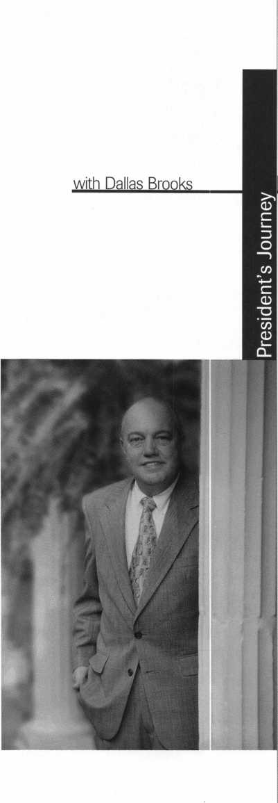

M

If you read my column regularly, then you know I’m a firm supporter of member participation. With this year’s election upon us, its important that all of you share this feeling. Every vote counts and with enough participation, we can make our association more cohesive than ever! Remember, the officers that are up for election this year are as follows:

President

Director - Southeast

Director - Northcentral

Director - Southwest

In this very issue of Keynotes (pp. 22-23), you’ll find biographical information on each of the candidates, vital details on voting, the meeting of the membership and even a ballot for easy use. Everything is right here, so don’t delay! Votes need to be received by July 8 for a meeting of the Membership that will be held the following day.

Outside of the election, ALOA ’99 is also on the horizon. I don’t know about the rest of you, but Cincinnati’s been on my mind since I left last year’s convention in Nashville! From the looks of things, this year’s convention and expo is shaping up to be an exceptional event.

Just as I encourage each and every one of you to send back the ballot that’s in this magazine, I hope everyone can make the trip to Ohio next month.

Next month, you will see my final pennings in Keynotes as we will soon have a new president. Although I’m eager to see an increase in voter turnout, I am a little emotional about vacating my post as ALOA President.

With that, I will use what time I have left to urge you to take pride in ALOA and cast your vote today!

Dallas C. Brooks President

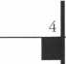

Keynotes

June 1999

Kwok-kei Leung „

Henry Raymond

Toshihiro Asano

Stewart Levine, CML

Charles Robertson, CML

Mary Ohmit, CPL

Yuriko Yanai

Jack Hobin, CPL

Allen Konrath

Salvatore Dulcamaro, CML_

Myeong-Rae Cho

William Neff, CML

David Lowell, CML

Thomas Freehling, CML

Dana Barnum, CML

John Heckman, CML

Jeanne Lodge, CML

Barry Leas, CRL

J Thomas Hood, CML

Lawrence F. Smith, Jr., CML

Danny Rudd, CPL

John Elliott, CML

Larry Warnick, CML

Roy Renderer, CML

James Watt, CML

Robert Carroll, CPL

Robert DeWeese, CPL

Diana Barnum, CRL

Barbara Watt

Jim Williams

Anthony Ramunno, CML

Jerome Cohen, CML

David M A Federico

Eugene Altobella

Elvis Hammerschmidt, CPL

Marian Swann, CRL

Charles Cole, CML

John Dorsey, CPL

D. Michael Lee, CPL

James Fowler, CML

David Harris, CML

John Kerr, RL

Ronald Heidzig

Joseph Ferrero, CML

James Cawby, CML

Philip Rovenolt, CPL

Michael Robinson, CRL

Brian Reetz

A I

The

_66

_65

_64

_61

_51

_49

_39

_38

_35

_33

_32

_31

_31

_30

_28

_26

_24

_24

_24

_24

_24

_23

_23

_23

_22

_22

_22

_21

_21

_21

_21

_20

_19

_19

_18

_18

_18

_18

_17

_17

_16

_16

_16

_16

_16

Best.

Walter Thomas

William Grant, CRL Keizo Takahashi, CRL Gary Teams, CPL William McElheney, CML William Lee Russell Fuller, CRL Rex Parmelee, RL James Gruber, CRL_ Robert Duman, CML

Daniel Landry

Edwin W Scott

Peter Gauthier, CPL Frank Hartung, CML Jon Griswold, CML_

PaulSouber

Richard Sievers

Joe Lee, CRL

Steven Spiwak, CRL _ Robert Rodocker, CRL_ Keiryu Tsukishiro, CRL Rolando Bouza

Lonnie McKinney, CML James Brickler, CRL _

John Engel, CRL

Donald Shiles

Eric Veal

Herbert Dusenberry, CML

Raymond Lusk, CML

Robin Horsley

Thomas Demont, CML_ Ernest Wright

William Wickward, CML .

Lester Brodsky

Joseph Whitaker, CPL

Dale Knowles, CPL

Michael Groves

s Club?

You can earn membership in this prestigious club by recruiting just 10 new members for ALOA.

*Any ALOA member may participate.

What do I get?

When you recruit 10 members, you receive a handsome blue blazer with a President's Club crest. For each additional five members you recruit, you receive a lapel pin with gold-filled numbers, indicating your recruiting successes.

You also get the satisfaction of knowing that you are helping your association, helping your industry grow, and you are helping fellow locksmiths achieve success.

How do I get started?

Contact the ALOA office for a supply of applications (800) 532-ALOA or FAX (214) 827-1810. One President's Club credit is awarded for each new applicant. Credit is awarded only after the membership application is approved. However, the credit will apply for the period in which the application is received. Failure to identify yourself as the sponsor on the application form at the time it is submitted to ALOA for processing will forfeit any credit.

*ALOA Board of Directors not eligible for membership in the President's Club.

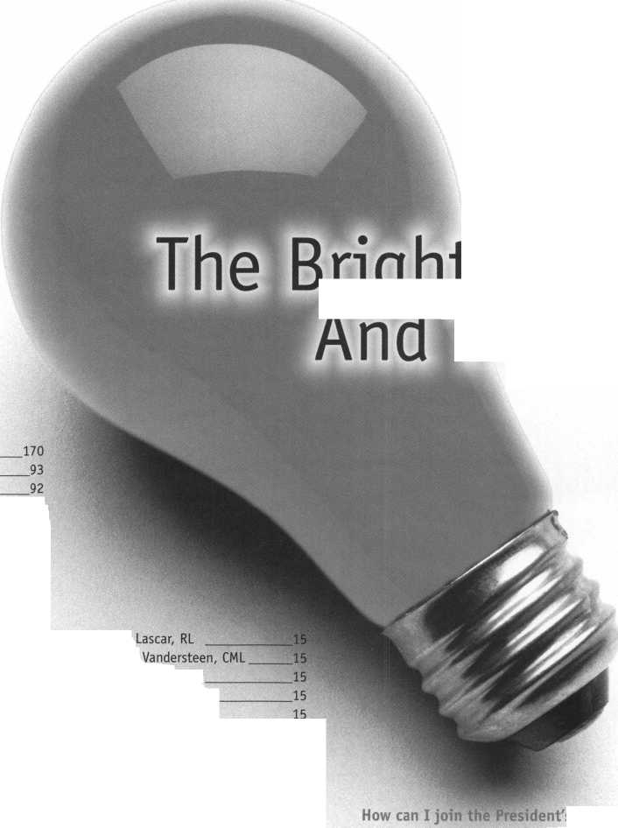

**JULY 25—31**



Into classes, into networking,  
into the latest products.

This year, don't miss the best locksmithing trade show and education event of 1999-the ALOA Convention and Security Expo. Discover the city that boasts Fountain Square, riverboats, water parks and a breathtaking river view from Mt. Adams.

See you at the pool (the talent pool).

For more info, call 800.532.2562  
or check out [www.aloa.org](http://www.aloa.org)

core

* Crime Does Not Pay

According to news sources in Charleston, SC, a man tried to steal an automobile by requesting service from a locksmith. The event took place at a shopping mall where the crook contacted a local locksmith to open a locked car. After it was opened, the man then pretended to have lost his keys and asked the locksmith to cut a set of keys.

Soon, the actual owner of the car showed up and demanded to know what was going on.

Persistent, the crook insisted that the owner must be at the wrong car and tried to send her away. The man was apprehended and sentenced to a bond hearing in Charleston. Yet another situation for locksmiths to be wary of.

(Editor’s note: Thanks to ALOA member Lee Griggs for bringing this story to our attention.)

* On the Web

The following are new industry websites that provide product and technical information:

Akron Hardware launched its new site at <http://www.akronhardware.com>. The site provides a company history, staff email addresses and product information on door hardware from Corbin Russwin, Yale, Norton, Rixson, Sargent, Arrow, Adams Rite, Stanley, Ives, Locknetics and Dorma.

Trico Manufacturing Corporation, a leading manufacturer of lubrication equipment is now at [www.tricomfg.com](http://www.tricomfg.com).

The site offers product and service information and has an on-line catalog to be ordered via the internet. It also has a cross-referencing feature that will link the user to thousands of lubrication manufacturers products.

ALOA is now offering PRP/STPRP testing once a month in its headquarters at 3003 Live Oak, Dallas, Texas 75204. Call (800) 532-2562 for more details.

CRLs

Mark D. Dolin, Yuba City, CA

Koichi Fuji, Okayama, Japan

Shouichi Fujiwara, Chita-Gun Aichi-ken, Japan

Tomonori Harada, Nagasaki, Japan

Isamu Hashimoto, Toyama-City, Japan

Veno Hiroki, Hiroshima, Japan

Sugiyama Hisakazu, Athugi Kanagawa, Japan

Hidetomo Kimura, Yokohama, Japan

Yoshizawa Makato, Tokyo, Japan

Masakatsu Mirooka, Morioka, Iwate, Japan

Masahiro Muto, Shibuya-KU Tokyo, Japan

Nobuharu Nagashima, Tokorozawa-Shi, SS, Japan

Seiji Nakamura, Himeji, Japan

Yoshiak Nakamura, Kawasaki, Kanagawa, Japan

Haruisha Ogawa, Fukui, Japan

Yuuji Sagawa, Kodaira-Shi, Japan

Toshio Sakamoto, Tokyo, Japan

Tokuno Shigeru, Yokohama, Kanagawa, Japan

Kazuaki Shinomiya, Sumida KU, Japan

Keizo Takahashi, Yokohama City, Japan

Norimasa Takahashi, Numazu Shizuoka, Japan

Tetsumasa Takahashi, Yokohama, Japan

Tadashige Tani, Shinjuku-Ku Tokyo, Japan

Toshhihiko Tsuaguchi, Koganei Tokyo, Japan

Keiryu Tsukihiro, Tokyo, Japan

Yoshiro Watanabe, Tokyo, Japan

Shinji Yano, Fukuoka, Japan

Suzuki Yoshiharu, Edogawa-KU Tokyo, Japan

• We’ve Got Yet Another Winner!

That’s right! We have a lucky winner from the April issue’s Back Page Music Appreciation Quiz. He is Craig DeYoung of Hamilton, Mich. He correctly answered the tough music trivia questions and will receive tickets to the Cincinnati Symphony. Here are the answers for all curious contestants.

1. “Tangled Up In Blue”
2. Virginia
3. “Henry the VIII”
4. “Song Sung Blue”



• Obituaries

ALOA bids a reluctant farewell to some of its prized members. We offer our sincerest condolences to the friends and families of the following individuals:

John Runyon, 72, of Largo, Fla.

Robert Baehr, 55, of Roselle, 111.



A & B SAFE

CORPORATION

#1 choice of safe specialists  
& security consultants

A & B is a leading manufacturer of quality  
depository safes & chests.

UL rated composite safes  
TL-15 TL-15/6 TL-30 TL-30/6.

Custom safes manufactured to your  
specifications.

* fire safes • vaults class 1,13, IG
* insulated files • chests
* truck safes • wall safes
* gun safes • media/data safes

OVER 75 MODELS IN STOCK  
SHIPPING YOUR ORDER  
WITHIN 24 HOURS

For fast accurate quotes call

1-888-723-8054 • 1-609-863-1186  
or fax to: 1-609-863-1208

171 South Delsea Drive  
Glassboro, NJ 08028-6237

June 1999

Keynotes



Upcoming

Events



Dept)

Indicates ALOA ACE (

Indicates PRP Sitting |

**l** Class

mm

JUPiE

2-6

ELF Convention Hotel Haarlem Zuid Haarlem, Netherlands +31-23-537-69-07 (fax)

5

Investigative Locksmithing I Class

Towson, MD

Ramadalnn

Loch Raven Blvd. & Beltway 695 IAIL

Rooms: (800) 272-6232 Don Shiles (reservation):

(800) 598-9491

Lenny Podgorski (reservation):

(410) 516-8269

5

Ace Classes Birmingham, AL Alabama Locksmiths Assoc. Contact: James Turner (334)793-5060 (334) 671-1405 fax

5-10

DHI Technical School Seminar Arizona State University Tempe, AZ

Contact: (703) 222-2010

6

5th Annual Locksmith Swap Meet and Olympics Quality Inn Hotel Lyndhurst, NJ Contact: Jeff Sitar (973) 777-0620

11-12

DHI Continuing Professional Development Seminar Renaissance Cottonwoods Resort

Scottsdale, AZ (703) 222-2010

12

**^** ALOA PRP Sitting

ALOA

Dallas, TX

Contact: David Lowell (800) 532-2562

1. 827-1810 fax

13

/ALOA PRP Sitting IDN-ACME Houston, TX

Contact: W. Wayne Hilliard

(504)837-7315

(504) 837-7321 fax

19

MBA Training Safe Deposit Locks Nicholasville, KY (888) 622-5495

20

MBA Training Time Locks Nicholasville, KY (888) 622-5495

26

2nd Annual Swap Meet & Family Picnic Wisconsin Indianhead Chapter Valley Builders Eau Claire, WI (715) 832-4207

JULY

10

**fk** ALOA PRP Sitting

ALOA

Dallas, TX

Contact: David Lowell (800) 532-2562 (214) 827-1810 fax

10-15

DHI Technical Schools Arizona State Univ Tempe, AZ Contact:

(703) 222-2010

22-25

DHI Chapter Leadership

Conference

The SunBurst Resort

Phoenix, AZ

Contact:

(703) 222-2010

25-31

ALOA ’99 Security Expo Cincinnati, OH (800) 532-2562

31

Locksmith Flea Market Milpitas, CA

The Silicon Valley Chapter of CLA 1444 S. Main Street Contact: Thomas Reeves-Messner (408) 262-5517 (408) 262-5517 fax [silvallock@aol.com](mailto:silvallock@aol.com)

/roysr

i

**^T\** ACE Classes Cincinnati, OH ALOA ’99 Security Expo (800) 532-2562

6-7

DHI Continuing Professional Development TBD

Seattle, WA (703) 222-2010

6-7

**£r\** ACE Classes Albuquerque, NM New Mexico Locksmiths Assoc. Contact: Steve Highland (505) 268-8663

(505) 268-8802 fox

6-7

ASTM Committee F-33 on Detection and Correctional Facilities Hyatt Regency Denver, CO

Contact: Cathryna Blackwell (610) 832-9737 [cblackwe@astm.org](mailto:cblackwe@astm.org)

8

**^** ALOA PRP Sitting Albuquerque, NM New Mexico Locksmiths Assoc. Contact: Steve Highland (505) 268-8663 (505) 268-8802 fox

14

ALOA PRP Sitting ALOA Dallas, TX

Contact: David Lowell (800) 532-2562 (214) 827-1810 fax

19-20

**^T\** ACE Classes Orlando, FL

SERLAC

Contact: Austin Curry, CRL

(813)837-8488

(813) 839-1825 fox

22

**^** ALOA PRP Sitting Baltimore, Md.

Clark Security Products Contact: Terri Burges (619)974-5273 (619) 974-5284 fax

22

ALOA PRP Sitting Orlando, FL SERLAC

Contact: Austin Curry, CRL

(813)837-8488

(813) 839-1825 fox

27-30

MLAs London Convention Contact: Dave Stokes 139 Wood Street Walthamstow, London, E17 3LX 01144 181 520 7450

SEPTEMBER

ii

/ALOA PRP Sitting

Dallas, TX

Contact: David Lowell (800) 532-2562

1. 827-1810 fax

15-19

GPLA Annual Convention

Philadelphia, PA

Jack Magee (registration)

(609)845-3434

Don Amole (booth space)

1. 288-5588 [www.gpla.org](http://www.gpla.org)
2. 19

TAOL’s 26th Anniversary Convention International Plaza Hotel and Conference Centre Toronto, Ontario (888) 272-8265 (416) 321-5115 fox

1. 19

Distributors Show Inn of the Ozarks,

Eureka Springs, AR Ozark Professional Locksmith Assoc.

Betty Gray: (501) 524-3660 day (918) 427-1066 evenings or

Bill or Janis Reves (501) 631-0017 day (501) 631-6406 evenings

OCTOBER

1-3

Jo-Van National Trade Show and Educational Seminar (416)752-7249

9

ALOA PRP Sitting ALOA Dallas, TX

Contact: David Lowell (800) 532-2562 (214) 827-1810 fox

10

/ALOA PRP Sitting Clark Security Products Baltimore, MD Contact: Terry Burges (619)974-5273 (619) 974-5284 fox

10

ALOA PRP Sitting Burbank, CA Clark Security Products Contact: Terri Burges (619) 974-5273 (619) 974-5284 fox

16-18

DHI 24th Annual Convention and Exposition Dallas, TX Contact: DHI (703) 222-2010

17

ALOA PRP Sitting Coraopolis, PA Penn/Ohio Locksmith Assoc. Contact: Martha R. Eggler

1. 676-8464

(216) 267-2511 fax

29-31

Convention

Basildon, London

Master Locksmiths Association

London Region

Contact: D. Stokes

0181-520-7450

0181-521-8376 fox

[MLA_LR@hotmail.com](mailto:MLA_LR@hotmail.com)

***Keynotes***

June 1999

Upcoming

Events

|  |  |  |  |  |
| --- | --- | --- | --- | --- |
| NOVEMBER | DECEMBER | MAY | 2001 | 2002 |
| 6-10 | ii | 1-6 | MARCH | JULY |
| 1999 Yankee Security | ALOA PRP Sitting | SAFETECH 2000 | 28-April 1 | 21-28 |
| Convention | ALOA | Birmingham, AL | MLANJ 2001 | ALOA 2002 Security Expo |
| Sturbridge Host Hotel | Dallas, TX | (214)827-7233 | Annual Convention | Rosemont, IL |
| Sturbridge, MA  Rob Mahoney | Contact: David Lowell (800) 532-2562 |  | Somerset, NJ (973) 267-8884 | (800) 532-2562 |
| (800)209-8266  11  + ALOA PRP Sitting ALOA | (214) 827-1810 fax  2000 | JULY  23-30  ALOA 2000  Las Vegas, NV | (973) 538-2248 fax [www.mlanj.org](http://www.mlanj.org) |  |
| Dallas, TX  Contact: David Lowell (800)532-2562 (214) 827-1810 fax | APRDIL  6-9  MLANJ2000  Annual Convention  Somerset, NJ (973) 267-8884 (973) 538-2248 fax [www.mlanj.org](http://www.mlanj.org) | (214) 827-1701 | JULY  15-22  ALOA 2001 Security Expo Baltimore, MD (800) 532-2562 |  |

BE A PART OF 1-800-LOCKSMITH!  
USE THIS NUMBER IN YOUR CITY  
& OWN THE MARKET!

We are looking for qualified locksmiths who want to expand their business  
and develop themselves into one of the largest locksmith operations

in their city. You will be authorized to use our logo and name

and we will advertise for you on radio and television.

Interested locksmiths will be able to "secure"

as large or as small a territory as they

desire. Territories will be based

on zip codes.

I



Call today for more information or to sign up!

June 1999

***Keynotes***

lr



Security

Marketplace

Adams Rite Manufacturing Co.

Adams Rite Manufacturing Co., introduces the 7300 Series, its most compact electric strike yet. Designed with an internally- mounted solenoid and a low-profile case, these strikes are easy to install, strong and secure. The 7300 Series will work for applications where space behind the jamb is tight, such as narrow stile or wood door jambs. The ultra­compact mechanism fits into jamb sections, as shallow as 1-3/16". The 7300 Series are listed for burglary resistance, have a holding force of 1500 lbs and are tested to one million cycles. Each unit is field reversible from fail-secure to fail-safe. The strikes have a low current draw. They come in 12 or 24 Volt DC and are available for steel, wood and aluminum jambs.

Adam Rite Manufacturing Co.

151 N. Kraemer Bird., Suite 100 Placentia, CA 92870 (714) 993-0898 (714) 993-6337 fax

Apollo

Apollo announces its new APACS ver. 2.1 Windows 95/98/NT based access control software. The software comes in three packages: Life, Standard and Pro. The Lite version provides on-line display of events, elevator, control, time, attendance, password- protected configuration of database, alarm linkage, event retrieval and sorting. The Standard version (in addition to the Lite features) includes colorgraphics maps, video badging and supports up to 3072 readers. The APAC PRO is an advanced alarm/access management system. It supports up to 256 workstations and 16384 readers of various technologies. The principle advantages are Mask and Reaction Features that allow alarm linkage via software instead of hardware. Both Standard and Pro provide CCTV interface. The APACS works with standard databases such as SQL and Access. The software provides a user-friendly environment for operating and processing of access/alarm information.

Apollo

3610 Birch Street



New Port Beach, CA 92660 (949) 852-8178 (949) 852-8172 fax [www.apollo-seurity](http://www.apollo-seurity). com

Cold Steel

Cold Steel introduces the Triple Action Folding Knife. The knife is only five inches long and weighs just 3.5 ounces, it is lightweight and easy to carry. The Triple Action Folding Knife features an AUS 10A stainless steel blade that combines cutting ability with strength and flexibility. The blade is precision honed to a razor sharp edge and the point is needle-sharp to pierce with the slightest touch. The handle on the knife is made of aircraft grade aluminum and roll engraved with a distinctive pattern, giving the Triple Action a finished look.

Cold Steel Customer Service 2128-D Knoll Drive Ventura, CA 93003 (800) 255-4716

HID Corporation

HID introduces new ISOPROX DUOPROX cards. HID's new flat laminated vinyl proximity and multi-technology cards can be printed edge to edge with dye sublimation printers. They also provide read range increases of up to 40 percent over previous cards. They have a thickness that meets ISO 7811 specifications. The DuoProx card combines proximity and magnetic stripe technologies while the SmartProx card combines proximity and contact smartcard technologies.

HID Corporation 9292Jeronimo Road Irvine, CA 92618 (800) 237-PROX (949) 598-1600 (949) 598-1690fax

Marks USA

Marks USA introduces grade one mortise locks with stainless steel latch and deadbolt. The latch is assembled with steel friction proof fingers enabling reduced pressure to

close the door. The deadbolt is constructed with two hardened steel pins to resist sawing. By utilizing stainless steel for the deadbolt, the lock will now qualify for use in most prison systems where mortise locks are required. In addition to these lock components, Marks has also standardized the use of stainless steel on most of its commercial knob and lever designs.

Marks USA

5300 New Horizons Blvd, Dept K-5 Amityville, NY 11701 (516) 225-5400 (516) 225-6136fax

Olympus America Inc.

Olympus America Inc. has introduced a remote visual inspection (RVI) system. It is claimed to be the smallest and lightest complete RVI video system available today. The portable unit is easily hand-carried to the surveillance site and is so lightweight that wheels are not needed on the carrying case. The complete system consists of an Olympus Series 6 Videoscope, an onboard computer, a versatile CCU, internal floppy disk drive, a light source and a six-inch diagonal LCD monitor. The monitor mounts on the Videoscope handle or on a telescoping pole in the case or it can be positioned remotely to suit the needs of the inspector. **Olympus America Inc.**

Industrial Products Group Two Corporate Center Drive Melville, NY 11747 (800) 446-5260 (516) 844-5620fax

Panasonic

Panasonic Video Imaging Systems Company (PVISC), Closed Circuit Video Equipment announces its enhanced line of power zoom lenses designed for operation with the company’s extensive line of 1/3" CCD cameras. The new WV-LZ61/15 Power Zoom Lens offers a long 15X range and the WV-LZ61/10 Power Zoom Lens provides a 10X range for general purpose applications. The WV-LZ61/15 offers long range 15X zoom operation (6 mm to 90

***Keynotes***

June 1999

mm) with a maximum aperture of F/1.6 (wide) and F/2.6 (telephoto). Additional fea­tures include CS-mount, auto iris (DC), motorized focus and zoom control. The WV- LZ61/10 is designed for more general-pur­pose applications with 10X zoom capability (6 to 60 mm) and a maximum aperture of F/1.6 (wide) and F/2.6 (telephoto). Additional features include CS-mount, auto iris (DC), motorized focus and zoom control. Panasonic (888)-PAN-CCTV

www.panasonic.com!cctv

Samsung

The Closed Circuit Video Division of Samsung Opto-Electronics America, Inc. introduces two dome camera surveillance units for use in a variety of indoor CCTV



**Tickets to the PGA Championship**

Medina Country Club in Chicago *courtesy Rosemont Convention Center*

**Round-trip Airfare for Two**

*courtesy Allstate Insurance*

**Four Nights at the Rosemont Hyatt Regency**

*courtesy Hyatt*

**Rental Car**

*provided by ALOA*

Security

I Marketplace

applications. SAD-129E/C is an attractive black and white dome camera accommodate surveillance unit and the SAD-229 N/P is an attractive color dome camera accommo­date surveillance unit. The features of both cameras include: built-in camera and fixed lens with 1/3" interline transfer color CD with two hundred seventy-thousand pixels. The fixed lens viewing angle is 92 degrees. In addition, a 360 degree adjustable viewing direction in a compact design. The cameras can be mounted in sheet rock or standard drop ceilings. The cameras are also easy to install and service.

Samsung Opto-Electronics America Inc.

40 Seaview Drive Secaucus, NJ 07094 (201) 902-0347 (201)902-1359 fax

Secura Key

Secura Key announces a low cost proximi­ty reader, the Radio Key RK-WM Proximity Reader, which is designed to integrate into any system requiring a Wiegand output. The reader has an attractive, stylish appearance and is small enough to mount almost any­where. Secura Key’s exclusive Dynascan tech­nology assures maximum performance in any environment. Read distances are up to 6". This completely potted unit is rated for extreme weather use and is vandal resistant. Includes a bi-color LED buzzer control, which are field selectable. Easy installation of the Radio Key-RK-WM requires that two screws mount the unit to a mullion, masonry wall, post or almost any surface.

Secura Key

20447 Nordhoff Street Chatsworth, CA 91311-6112 (818) 882-0020 mail@securakey. com

ALOA WANTS TO FIND OUT IF YOU

ARE PGA CHAMPIONSHIP MATERIAL

EnterThe ALOA Open Golf Tournament, sponsored by Yale Security  
Group Inc., and benefitting the ALOA Scholarship Foundation. The  
tournament will be held Wednesday, July 28, 1999, during the ALOA  
'99 Convention and Trade Show.

Entry includes breakfast, green fees, a golf shirt and hat, and  
the evening dinner event. Everyone who enters is eligible to win  
one of many incredible prizes, including golf clubs, equipment  
and clothing. And everyone who enters the tournament, or purchases  
a $100 banquet ticket is automatically entered in the grand prize  
drawing — A TRIP FOR TWO TO THE PGA CHAMPIONSHIP!

A $150 tax-deductible donation to the ALOA Scholarship Foundation  
reserves your spot. But SPACE IS LIMITED! Use the ALOA '99  
Registration Form and sign up now! For more information, call or write:

ALOA '99 Open Golf Tournament

3003 Live Oak Street  
Dallas, TX 75204  
1.800.532.2562



June 1999

Keynotes

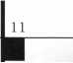

‘The ALOA Board of Directors decided not to endorse candidates for election to the Board, and I fully agree with this decision. However, as an individual, / believe it is very important for me to actively support the most qualified candidate for the presidency of ALOA. Of the announced candidates for this position, I must support John Greenan from Chicago, Illinois. John is 100% committed To ALOA. He worked very hard over the last several years to give all members of ALOA the ability to cast a vote by mail and to drastically improve the governance of ALOA. John Greenan will keep ALOA headed in the right direction. My ballot will be mailed with a check mark by John Greenan's name."

Dallas C. Brooks

Auburn, Alabama

“John Greenan was a member of the Strategic Planning Committee created in 1995 that mapped out the changes in our association which are in place today. Working with John in these and other ALOA committee meetings / found that he always put the needs of the membership first when decisions had to be made. As a former president of ALOA, I admired John's willingness to take a stand on important issues including, most recently, the Bylaws change that allowed vote by proxy last year at the convention and the support of the governance policy that is in place today. I feel that John will lead ALOA and its members to success in the 21st Century."

David Lowell, CML, CMS

Phoenix, Arizona

“Mr. Greenan has been deeply involved in legisla­tion that affects locksmiths for the past few years and I feel that he is well-prepared to lead our membership in this most important area. / feel that he will continue to support the governance process that is in place and will assure that the work on the policies will continue in a manner that will benefit the ALOA membership. There are many other reasons why / will support Mr.

Greenan, but / will simply say that it is my opinion that he is the most qualified candidate for the office of President."

John D. Cannon, CML

Alexandria, Virginia

“John Greenan’s consistent effort to create a positive Legislative Environment for the locksmith industry has added to the value of our profession. His active support of the current governance policies assures him of my full support as president of ALOA."

Randy L. Simpson, CML

Houston, Texas

“John’s expertise in Leadership and his promotion of the locksmith industry make him an excellent candidate for this important position."

John C. Magee III

Woodbury, New Jersey

To my  
fellow  
locksmiths

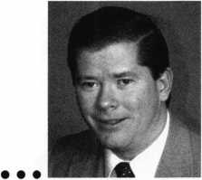

I am running for the office of ALOA president because of my commitment to seeing our members succeed as they move into a new century. The road to that success is by building upon the positive strides we already have made. We have given back to members a voice in who runs their association and improved the way the board interacts with the ALOA headquarters. The positive improvements made to membership services can already be seen by the amount of new educational programs now offered, the diminishing negative legislation and growing attendance at Convention. I am committed to keeping us moving in this positive direction.

I am also committed to seeing ALOA provide more for the members by moving the association forward in the following direction:

* For you to succeed, ALOA needs to create more opportunities for our members by building closer ties with manufactures

and distributors.

* For you to succeed, ALOA needs to improve the public’s awareness of our profession and the variety of services we can offer our customers.
* For you to succeed, ALOA needs to be a resource for all locksmiths, especially in the areas of education and legislation, by working closer with regional locksmith associations and chapters.
* For you to succeed, ALOA needs to help members take

a business approach to their profession by offering more resources in this area.

* For you to succeed, ALOA needs to provide expanded educational opportunities in the rapidly growing fields of mechanical and electronic security.

I have had the honor of serving on the ALOA Board as the Northcentral Regional Director for six years, and feel confident about the progress the association has made and would continue to make if elected as your president. I am committed to ALOA’s success to ensure you are successful in the next century.

THIS ADVERTISEMENT PAID FOR BY JOHN GREENAN.

Applicants

For Membership

Dept

***The following applicants are scheduled for clearance as members of  
ALOA. The names are published for member review and comment prior to  
July*** *1****,*** *1999****, to ensure applicants meet standards of ALOA’s Code of Ethics.  
Protests, if any, should be addressed to the Membership Department and  
must be signed. Active Membership applicants (A) have worked in the indus-  
try two or more years. Allied Membership (AL) applicants are not  
locksmiths, but work in a security-related field. Apprentice Membership (AP)  
applicants have worked in the industry less than two years. A***

USA

ALABAMA

Gardendale

Shelton A Cummings, A

Montgomery

William E Garrett, AP Alan H Pyron, A **ARIZONA**

Glendale

David Kitchen, A

Peoria

Harry D Byers, A SPONSOR: William Lee

Phoenix

Robert A Charella, AP SPONSOR: William Lee

CALIFORNIA

Irving

G Yee, A

Newport Beach

Paul Linder, A

R.S.M.

Jeff Zettel, A

Ridgecrest

John A Robb, A SPONSOR: Gregory Perry

San Diego

Donald L Smith, A

Soqeul

Scott M Edelstein, A

Vallejo

Jefferson L Folks, A SPONSOR: Arthur Patch

West Hills

Michael Katz, A

COLORADO

Denver

Arlin H Lund, A SPONSOR: Kent Smith

Englewood

Brian Hambleton, A

La Junta

Thomas R Gonzales, AP SPONSOR: Gordon Racine

Security

Russ W Cottrill, A SPONSOR: Bruce Eagan John B Harris, A SPONSOR: Bruce Eagan Marc J Serravezza, A SPONSOR: Bruce Eagan

Westcliffe

William M King, A

CONNECTICUT

Old Mystic

Kenneth J Donovan, A

DELAWARE

New Castle

Rocky R Hershey, A SPONSOR: David Braun

FLORIDA

Homestead

Linda Varnadore, A

Kissimmee

Patrick M Gat ward, A

Largo

Nick Radziseski, A

Miami Lakes

Rose Guglielmo, A

Miami Beach

Ramon Hernandez, A SPONSOR: Joseph Nogueras

GEORGIA

Atlanta

Richard E McGee, AP

Rome

John W Ross, AP

IOWA

Cedar Rapids

Harold G Shoemake, A

ILLINOIS

Arlington Heights

Christopher B Germana, A

Elgin

Len Stoia, A

Vernon Hills

Rich Bond, A

INDIANA

W Lafayette

Steve Y Davis, AP

KANSAS

Marysville

Doug G Ackerman, A SPONSOR: Elvis Hammerschmidt

LOUISIANA

New Orleans

Derek L Douget, A

MASSACHUSETTS

Concord

Kenneth T McAdams, A

Deerfield

Peter J Bernard, A SPONSOR: Russell Fuller

MARYLAND

Towson

John Butler, A

MICHIGAN

Grand Blanc

Marc A Dearing, A

Mattawan

George M Coffey, A SPONSOR: Terry Bussema

MINNESOTA

Lake Elmo

Tracy Little, A

Stillewater

Jim Duncan, A

MISSOURI

Jefferson City

Timothy C Doane, A SPONSOR: Bruce Jamison

Knob Noster

Kevin W Haynes, AP

NORTH CAROLINA **Cary**

Jonathan M Herman, A SPONSOR: Jeanette Busse

NEW JERSEY

Brielle

Dave Bryant, A

Cherry Hill

William H Busse, AP SPONSOR: Carlton Prescott **Colonia** John Marchuk, AP SPONSOR: William Young

Lodi

Stephen J Bell, A

Randolph

Salvatore Scarpa, AP

Wall

Benjamin J Stoner, AP SPONSOR: David Rible

Woodbridge Twp

Walker J Glen, AP SPONSOR: William Young

NEW MEXICO

Albuquerque

Scott E Green, A SPONSOR: Debra Coleman

NEVADA

Las Vegas

Anthony L Roberts, A Ruben Romero, A **NEW YORK Binghamton**

Stirling W Baldwin, A SPONSOR: William Ryan

Castle Point

John W O'Dell, A SPONSOR: Joe Lee

East Syracuse

Kevin M Slomn, A

Glendale

Peter Bertolino, A SPONSOR: John Shea

Islip

Eugene A Baumann, AP SPONSOR: Robert DeWeese

OHIO

Canal Fulton

Randall D Grage, A

North Canton

Ronald L Burns, A

Pomeroy

David K Vujaklija, A SPONSOR: John Barton

Walbridge

Scott W Lucas, A SPONSOR: James Pirolli

PENNSYLVANIA

Aliquippa

Michael F Jabaut, AP SPONSOR: David Pavlakovich

Malvern

Michael A Schell, AP SPONSOR: William Young

SOUTH CAROLINA **Clemson**

Matthew S Miller, A SPONSOR: Kenneth Ellis

SOUTH DAKOTA

Pierre

Michael D Wells, A

Spearfish

James W Treadway, A

TENNESSEE

Knoxville

Steve E Delaney, AP SPONSOR: Marian Swann

Memphis

Reuben J Cashon, A SPONSOR: Jackie Clark

Morristown

Jeffrey A Chappell, AP SPONSOR: William Vaught

Nashville

Chris J Abigt, AP

TEXAS

Dallas

Ed Lockey, A Paul J Marshall, AP SPONSOR: David Lowell Robert V Walker, A

Houston

Keith Johnson, A

Humble

Donald R Lanmon, A SPONSOR: Darrel Moore

Killeen

Hiran Medina, AP

VIRGINIA

Arlington

David Jacobi, A SPONSOR: Gary Baldino

Richmond

Steve Wilkinson, A

Salem

Dave Paterno, A Bernd Wempen, A

VERMONT

Burlington

Bradley D Manchester, AP SPONSOR: Russell Zehnacker

WASHINGTON

Redmond

John Sekreta, A

WISCONSIN

Antigo

Phil G Tautges, A

Crandon

Adam D Short, AP SPONSOR: John Engel

West Allis

David B Fairbrother, A SPONSOR: John Soderland

AUSTRALIA

Nunawading Victoria

Ian Larner, A

BAHAMAS

Freeport

Charles S Cox, A SPONSOR: Charles Robertson

CANADA

MONTREAL

Guy LeBlanc, A

BRITISH COLUMBIA **Richmond**

Ken Barry, A Tom Urquhart, A **ONTARIO**

Maryhill

Steve Elvy, A

Orillia

Gordon R Vander, A

Toronto

Monique Elliott, A

QUEBEC

Kirkland

Serge Blouin, A

UNITED

KINGDOM

ENGLAND

Chelmsford Essex

Peter Moule, A

EL SALVADOR

San Salvador

Calixto Quan, A SPONSOR: William Lee

JAPAN

Fukuoka-City Ken

Akemi Kuroki, A SPONSOR: Toshihiro Asano

Ichihara-City, Chiba

Hiroshi Watanabe, A SPONSOR: Toshihiro Asano

Kuki-City Saitama-Ke

Toshihiko Hirose, A SPONSOR: Toshihiro Asano

Matsudo City Chiba

Shinichi Hosoya, A SPONSOR: Toshihiro Asano

Tokyo

Naoto Sugimoto, A SPONSOR: Yuuji Sagawa

Toyama

Tsuyoshi Hashimoto, A SPONSOR: Isamu Hashimo­to

Yokohama Kana Wa

Tadashi Sakura, A SPONSOR: Keizo Takahashi

TOKYO

Adachi

Seiji Yabe, A Shinjuku-Ku Takeshi Kihara, A SPONSOR: Toshihiro Asano

KOREA

Dong-Rae, Pusan

Kim Young-Hwa, A SPONSOR: Man Seo

Pusan

Yang Young-Ho, A SPONSOR: Man Seo

NORWAY

Bergen, Ulset Stein E Hansen, A

TURKEY

Bakirkoy, Istanbul Sinan Okay, AP SPONSOR: Niyazi Okay

13

June 1999

Keynotes



A common request for many locksmiths is a rekey of one or two locks in an existing Master Key System. It is very likely the most dangerous job that most of us perform. It is dangerous because we usually don’t know very much about the system, its design or implementation. What is the size of the system? How many levels of keying are part of the system? Is there any cross keying in the system? Was the original system pulled out of a shoe box or was it properly designed? Were the locks pinned from a pin kit or was a file used? How old are the locks and how much wear do they have?

One first step you can take is to ask the customer if he has a copy of the system records. Typically, the customer won’t even know there could be any. This does give you a good chance to explain to him the importance of the records to be able to guarantee no interchange in the system. You can explain that interchange is a condition in which a key opens locks it isn’t supposed to open. In a business MK system, that would mean that someone can get into an office that isn’t theirs. In an apartment house, they might get into an apartment that isn’t theirs. In all cases, interchange results in a very large liability. With all of this explanation, he should understand why you want the records and might even be willing to cover your expenses for decoding the existing system.

If he won’t cover your expenses for decoding, at that point you have three options:

1. Offer to do the decoding with the under­standing that all future rekeys will be done by you.
2. Turn down the job.
3. Offer to do the job without decoding only if he is willing to sign a release which indemnifies you.

Option 1 is something you will have to figure out on your own to be sure that you aren’t going to lose your investment in time and work. If the customer has enough business, you might regain the investment if you get all of his business.

I usually choose option 2 more often than the others since I am not willing to accept the potential of doing the job to a lower standard or at my own risk.

Option 3 may be viable for you, I suggest checking with an attorney to be sure.

14 | KeynotesJune 1999

There is only one reason you need to decode the existing system. You must be able to regenerate the original system and then eliminate from that system all keys that have already been used. That will allow you to select new combinations for rekeys without the potential of interchange. Inform the customer that first you will have to decode all of the existing keys, be sure he under­stands that you don’t have to decode every copy of every key, just one copy of each different key. With that decoding done you can then look at the combinations and figure out how the original system was developed.

Depending on who installed the original system, there are three different methods that could have been used. The first is called Total Position Progression (TPP), and means that there will be a master pin in every pin chamber in every lock. The second method is called the Rotating Constant Method and every lock will have at least one pin chamber that does not have a master pin in it. If the Rotating Constant Method was used correctly, every lock will have exactly the same number of pin chambers that without a master pin. The third method is one you don’t want to find, it’s called the “shoebox method.” That means that the original installer was a locksmith who didn’t know the proper way to master key. You will find some locks with one master pin total and others with a master pin in every pin chamber. If you find the same thing I usually do, you will also find that some of the plugs have been filed and/or some of the driver pins are really bottom pins with the pointy end down, or even some empty pin chambers.

Decoding the keys will give you the best indication of how the system was developed. You will know which key is the Master Key and you can compare the combinations of all the other keys with the MK. If you find that the change keys don’t contain any of the cuts of the master key in the corresponding position, then it is a TPP system. If the change keys all have the same number of cuts that are equal to the MK in the corre­sponding position, then it is a Rotating Constant system. You may even be really lucky and find that all of the change keys have exactly the same cuts that correspond to the MK. In that case you have a Rotating

Constant system where only one pattern of progression has been used and the rekey or addition of a few locks is as simple as using another pattern of progression.

If it turns out to be a shoebox method, advise the customer that you cannot supply new combinations with any confidence and recommend that the entire system be rekeyed. That will be a rather large expense if done all at once, so give the customer the option of having you start a new key system for the locks he needs now and eventually, have all the other locks rekeyed to this new MK. In most cases, the customer is just concerned that he can get into all of the locks and won’t mind having to carry two keys until all the others can be rekeyed.

If it is a TPP system, simply create a progression list for the system and cross off any used combinations. Ninety-nine percent of the time you will cross off combinations only on the first page of your progression list and typically they will have been used from the upper left down and then in column two, three, etc. If you find that there are some missing numbers in the middle or at the beginning of your list, play it safe and don’t use them since they were probably used before. You might want to go back a couple of pages to start using combinations just to be safe.

There is one other type of situation you may find. You may discover that almost all of the keys fit the TPP format except for a few that seem to be Rotating Constant. You may even find that not all of the seemingly Rotating Constant keys are the same and some will have more constant cuts from the MK than others. This can have two meanings:

1. The system has more than two levels of keying, or
2. Someone has been there rekeying before you and didn’t do your quality of work. They probably just pulled a few keys out of the nearest Shoebox and keyed them into the system.

You can verify the number of levels of keying in the system from your customer. If he says there are only two that he is aware of, advise him of the interchange that can result from the Shoebox keys and tell him you really need to rekey them as part of the job.

In a TPP system, a change key with just



one cut from the MK will be able to open four of the regular cylinders in the system. A change with two MK cuts can open 16, three will open 64, four from the MK will open 256. Do you know how many could possibly be opened by a six pin key with five cuts from the MK?

Decoding the existing keys and regener­ating the system isn’t the end of this job. You

*t £ *

% I1<9 M

**TO AW EXISTING MASTER. KEV SVSTEM**

By Billy B. Edwards Jr., CML

also have to inquire about the keying of the  
locks. For example, are there any doors that  
have to be opened by more than the MK and  
one change key? If he answers “yes,” then  
there is cross keying involved in the system  
and that means that you will be taking some  
locks apart to see how many keys can operate  
that lock and you will have to figure out the  
combinations of all the keys that can operate  
and make sure you eliminate them from your  
list of potential new combinations.

Even if he answered “no” for the cross  
keying, you should take apart a couple of the  
cylinders from what seem to be the most  
frequently used doors. What you will be  
looking for is wear. If there is a lot of it, it  
may be wise to use four increments instead of  
two in order to compensate for it. The last  
thing you want is a call back for interchange  
after all your work decoding the existing  
system to prevent it. And don’t forget, the  
entire range of all the depths in a lock with a  
.015" increment is a little less than the  
thickness of three pennies.

The biggest question may not be the one  
your potential customers asks, “Can you  
make my master key work these locks?” It  
may be instead, “Do you want to accept the  
liability for doing anything less than a  
complete rekey?” Just remember, most of our  
customers knowledge of locks stops at “insert  
and turn.” You may have to do a little



educating before he will realize that you

aren’t trying to rip him off instead of really

doing a quality job. By the way, a six pin key

with five cuts from the MK has the potential to open 1,024 locks in the system.

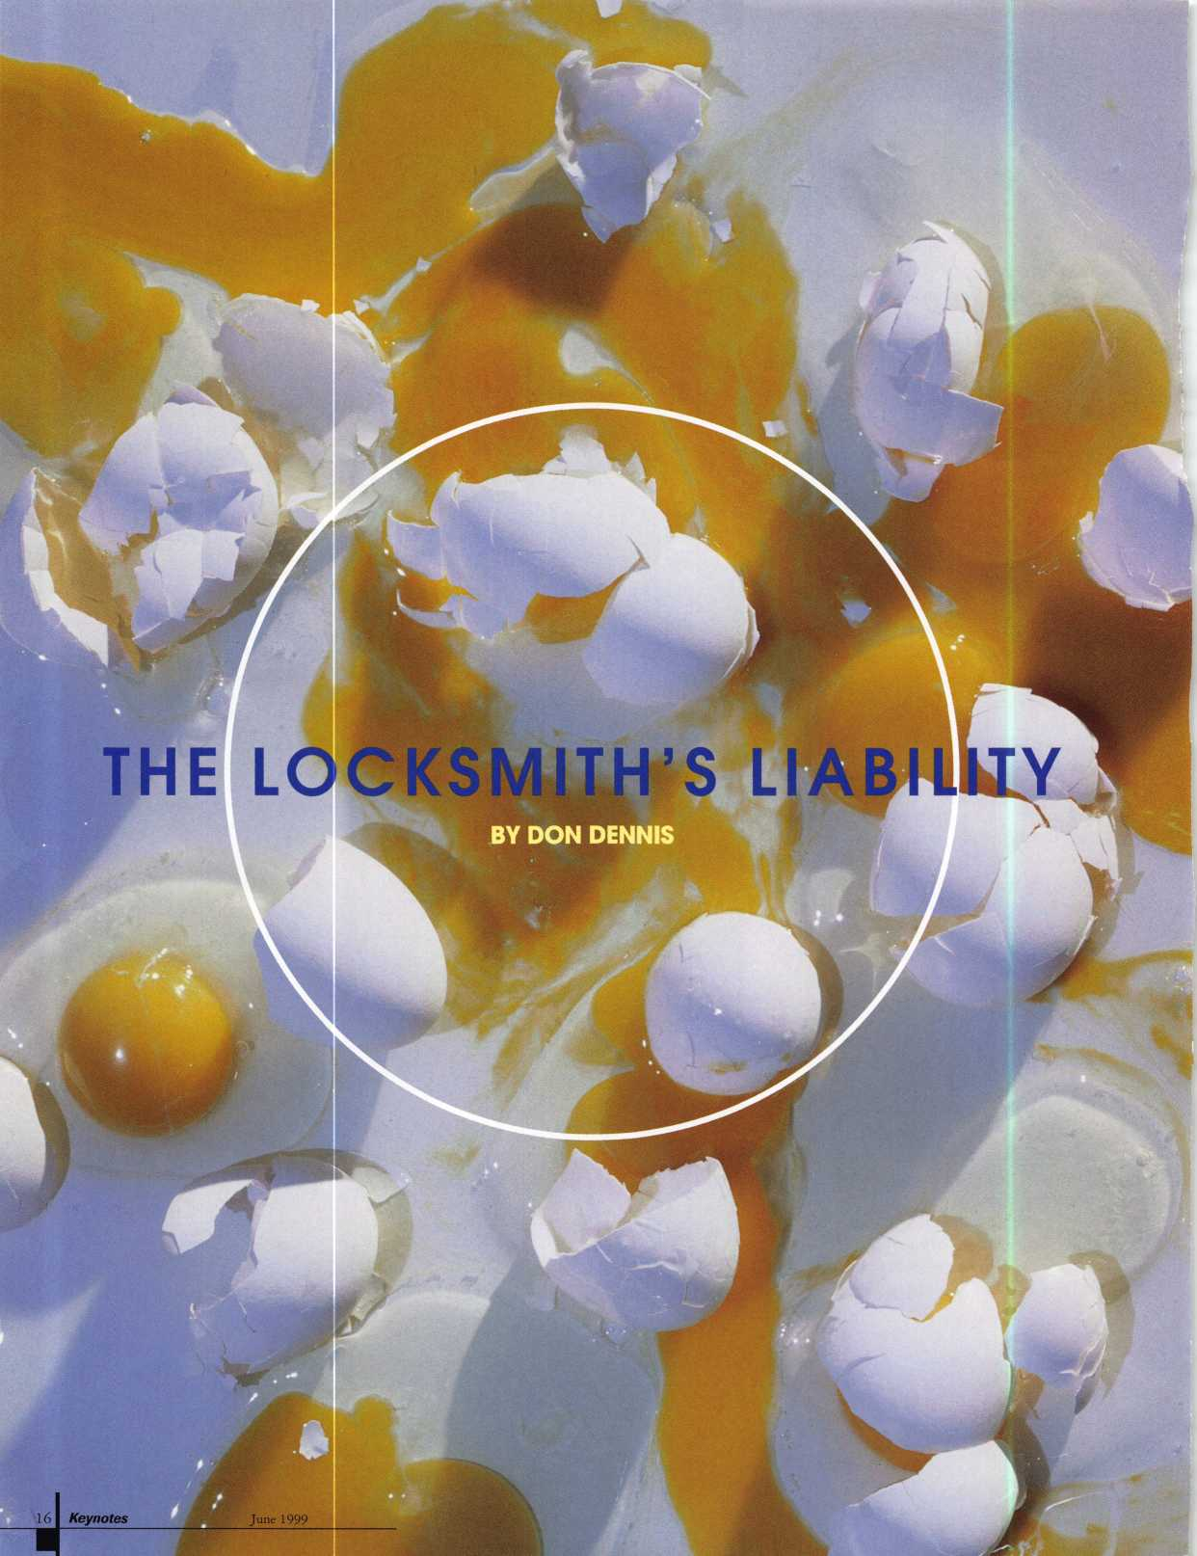

If you can work with the complexities of master keying,  
encryption is but one more step.

Have you ever wondered what kind of a disaster a locksmith would have if he were burglarized? It would do very little for his reputation. What if the burglars confiscated all of his customer files that dealt with master keying? Just think of all of the “free” work that would be required! You would have to hire guards, to change combinations on front doors and gates and have to return to redo all of the systems once you covered all of the initial problems! Customers would question your viability to handle their system not to mention your conscientious­ness. It would be a nightmare!

There is one thing that can be done to help safeguard such a mishap. It is relatively simple and very inexpensive. It will cost you a little time and some effort in organization.

It deals with encrypting your work! Now don’t run off! If you can work with the complexities of master keying, encryption is but one more step. It is a step that can be as simple as you wish to make it. Keeping it simple is important since you want to get into the system and make a new product for the customer as quickly as possible. The next question is how does one start?

**GETTING STARTED**

When you examine your shop and the method you employ to manage a customer and their system, you will find that there are three elements to the system. There is a set of keys that help you work the job. These keys generally contain the new master key and the old master key. There is an entire master key system that will be used on the job. There is the customer’s file with the portion of the master key system that you are imple­menting on site. Sometimes, the master key system will have been duplicated and becomes a part of the customer’s file along with the portion that applies to the location and a map of the premises. There is no encryption involved. Generally, I have found that the locksmith will keep a set of keys in

their own key box on a numbered tag. That’s not to say that I have not witnessed keys being tossed into the same file folder and placed into a file cabinet! Without a lock on the file either! This “disaster in the making” can become a manageable situation with proper safeguards.

**THE FIRST STEPS**

If we used only one code word for encrypting every system, it may become very easy for someone to see the commonalties and break the code. This is what I would propose.

You need a master code word. This master code word starts the encryption of everything that is found in the heading of all customer file folders.

You need a list of code words. This list of code words will be used for coding individual master key systems in the customer files. Give a number for each word in the list starting with the number “01”.

You need to have several master key systems both five and six pin numbering each one of them consecutively with its own number and keep them all in a single file.

You need a key box with key tags starting with “01” on up until you have all of your customers with a designated tag and extra tags for future expansion.

**THE ENCRYPTION PROCESS**

There are lots of ways to encrypt your work. For this article, we will keep it simple.

A good encryption formula that works well for me is to pick a word or a two-word phase that has enough letters to accommo­date the numbers 0 through 9- An example would be “CONFUSABLE”. Take the word and add the numbers.

**CONFUSABLE**

**0123456789**

Another word could be “Copyrights” or

“Padlocking”. How about using “Convert­ible” and just “x” out the last “e”? You could use two words such as “indirect light” and remove any duplication of letters. This would make “indirect light” into “indrectlgh”. This is not a word but it would make guessing the word used most difficult.

When you get a new customer, indicate on their file folder the coded information that pertains to that particular customer using your master code word. Here is an example. Let’s say that we decided to use the word “confusable” for our master code word and the code word “copyrights” for this job. “Copyrights” had been given the number of 45 in your list. We also had a six-pin master key system with the number 21 that we were going to use. In our key box the hook was going to be number 30, which would hold the keys for this job (i.e. master key new and old). Keeping the above information in order, the top of the file folder would look like this: Jones Corporation / us-no-fc. You may also want to place other relevant information like phone numbers or address in the heading without encryption. The end result is that the Jones Corp. is using code word “copyrights”; master key system #21 from the master key file of systems; and the keys are in your box on hook #30.

We can see that the master key system number and the key hook number are easy enough to understand. What does one do with the code word “copyrights”? The word “copyrights” is used for this job to cipher and decipher every number that will appear in the Jones’ file that pertains to master key system #21. Here is an example. Let’s say the master key system #21 had a master key with the cuts “505894”. It would be ciphered using “copyrights” to read in the file as “iditsr”. If you really wanted to make things trickier, you could subtract a number before ciphering takes place. Here is an example. Let’s subtract two from each cut of the master key “505894”. It would become

I have.. .witnessed keys being tossed into the same file folder and placed into  
a file cabinet! Without a lock on the file either!

June 1999

Keynotes

“383672”. Ciphered using “copyrights”, the entry would look like “ytyghp”. Deciphering would be using the system by reversing it. The process that you would decide on would then be used to cipher the entire system in the customer’s file. An example would be for the key numbered AA1. The entry would appear as AAl-iditsr. Deciphered the actual key number and cuts on the key using the subtraction method would be AA1-727016.

How does one remember all of this? Most of it you won’t. You will probably keep a list of the code words and remember or keep

written down the master code word with its numbers. Use your shop’s safe to keep this list. I keep the master code word in a paper back copy of the Jefferson Bible and the list of code words in a book of Poetry by Robert Frost but then I have no employees. There is also a copy in the safe deposit box! That’s in case the place burns down. I have seen shops where this idea is used to control employees so no one but the hierarchy really knew what was going on. The main point is to remember that everyone is vulnerable to attack and this simply gives insurance and

Do you need Electrified...

|  |  |  |
| --- | --- | --- |
| o |  | o |
| Marray |  |  |
| o |  | o |
| o |  | o |

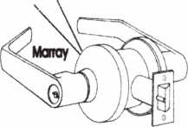

Trim  
Locks  
Hinges

Panic Devices  
Access Hardware  
Custom Modifications?

You Need To Call Marray

some peace of mind at a very small cost to the wallet.

You can use the web site links that are below if you are interested or if you may be fascinated enough to make this type of thing a hobby. Thomas Jefferson made an invention to help encrypt and decrypt messages. In fact the history of Cryptography goes all the way back to Caesar and possibly to the beginning of written language. Look at all of the work Archaeology is giving to Egypt and South American Cultures. It is safe to say that encryption is used heavily in our world today by governments and corpo­rations in their fight to keep things secret and safe. We as locksmiths have a responsi­bility to the craft as well as to our customer to safeguard the information that we have created and are entrusted with.

**USEFUL**

**INFORMATION**

The following list of web sites could be useful to expand your knowledge of Cryptography:

<http://www.ssh.fi/tech/crypto/intro.html>

<http://www.ftech.net/~monark/crypto/>

links/history.htm

<http://www.cryptography.com/resources>

/index.html

The following list of books could be useful in expanding your interest in Cryptography:

The Code Breakers by David Kahn ISBN :0684831309 Dec. 1996 $65.00

1-800-500-1449

Marray Enterprises, Inc., is an after-market modifier of locks,  
hinges, and panic devices. Located in the Silicon Valley of  
California, Marray uses precise computer controlled machin-  
ing to modify name brand hardware like Schlage, Von Duprin,  
Arrow, Baldwin, Bommer, PBB hinges and more! If you are  
looking for superior products with the best warranty, pricing,  
delivery and availability, call Marray. Your first source for UL  
listed & modified hardware.

ME

Marray ***enterprises, inc.***

At Marray, we’re not just modifiers, we’re Master Hardware Modifiers™  
1128 Walsh Ave., Santa Clara, CA 95050. [www.marray.com](http://www.marray.com)

June 1999

Between Silk And Cyanide by Leo Marks ISBN:0684864223 Junel999 $27.50

Enigma by Robert Harris ISBN:0804115486 Oct. 1996 $7.00

Cryptanalysis: A Study of Ciphers and Their Solutions by Helen Fouche Gaines ISBN:0486200973 Dec 1939 $7.95

Decrypted Secrets: Methods and Maxims of Cryptology by Friedrich L. Bauer ISBN:3540604189 Mar 1997 $27.97 jj

Note: All of these books can be obtained



..J Keynotes

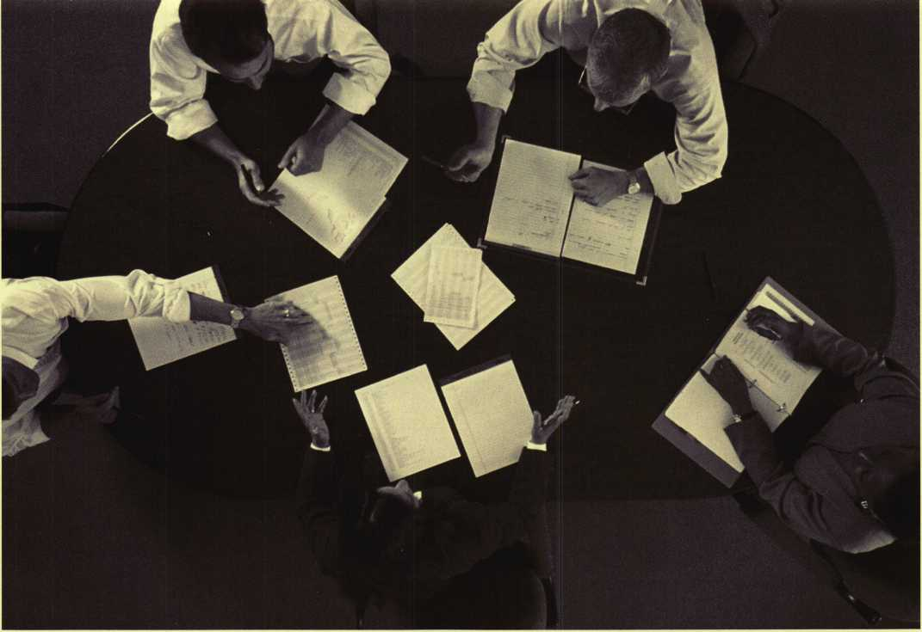

Holdi

Keyi



a Successful Conference

BY JEROME V. ANDREWS, CML

The purpose of a keying conference is to design a keying system that serves the end users’ needs. This system should be able to support the hardware and be serviceable for the practical life of the system.

The immediate product of the conference is a keying schedule. But the expansion specifi­cation for future growth and changes is just as important, regardless of whether the system is to be written in the field or by the factory. This requires a mix of technical and interpersonal skills.

One caveat for field written systems: a solid grasp of number crunching is mandatory. Locksmiths need to know total position progression and the rotating constant method, as well as manufacturer- specific keying limitations. Computer master keying programs are a tool. They will supply

an error free bitting list. However, they require input based on judgement and experience. If the bitting list is poorly designed, it is not the fault of the computer.

First, we will consider the keying confer­ences in a formal sense, as if for a large project. While it is possible on small projects to do the keying conference on the same visit as the site survey, large products require a separate meeting. Sometimes more than one meeting is needed. Then we’ll discuss some practical approaches that work regardless of the size of the project.

All meetings require preparation.

An effective meeting requires planning, and the responsibility for both preparation and outcome falls on you. It is normal to work with a contact or liaison for a given job.

However, even if someone else is the nominal leader, you must keep things focused.

You and the liaison should discuss everything from where the meeting location will be to who will sign off on the keying schedule. It is important to be familiar with the property prior to the meeting, either from the site survey or the use of prints.

Time should not be wasted while you study the subbasement you didn’t know was there.

In order that attendees are prepared to make decisions about keying, they must be informed of the purpose of the meeting, have at their disposal any required material like floor plans or hardware schedules and be given some expectations of what they will be asked to do. Providing a sample key system schematic is one way to help them understand the expectations.

June 1999Keynotes | 19

If you have this...

...then you have a key system schematic.

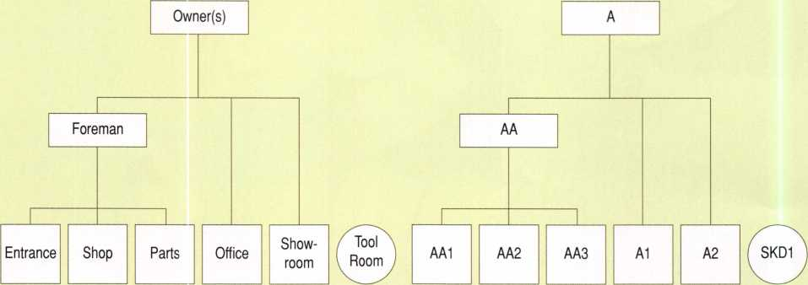

Figure 1—Ask the end user for an organizational chart. It leads directly to the key system schematic.

You and the liaison must decide what materials will be required, who will be responsible for providing them, by when, and who will distribute them to the attendees.

Everyone’s time is valuable. Attendees should know the location and time of the meeting, as well as the estimated length of the meeting.

Many find an outline or agenda for the meeting to be helpful. One possible way to begin is to review a suggested key system schematic for the project and give a short explanation of the keying symbols.

The pertinent agenda items are the key system schematic, the expansion specification and the production of at least a preliminary keying schedule.

Sketch a schematic and write out a statement of the expansion specification in language that the end user can understand. Keep the system as simple as possible. SKDs are safer than master keyed locks. Two levels of keying are preferable to three; three to four, etc. Encourage as much keying alike as possible.

Agreement should be reached on the key system schematic or some standard expression of the system architecture, i.e., two, three, or four levels of keying, etc. The expansion specification should be written. It will be required by the factory or the locksmith shop and will protect you as the specifier in the event of future disagreements as to the system architecture.

If it is possible to resolve all issues at the meeting, have the end user sign off on the schematic, the expansion and the keying schedule. If questions remain, determine who will answer them and by when, before closing the meeting. If the keying schedule is to be completed after the meeting, return it to the appropriate party for a signature.

20 | KeynotesJune 1999

This meeting is often the appropriate venue to raise the issue of system management and key control policies. For the retail locksmith, it is often an upsell opportunity for key control and electronic products.

Discuss how mnning changes will be handled. If another meeting is required, get the necessary commitments. Don’t forget to thank everyone for their time and participation.

Keeping tilings focused

Keep the purpose of the meeting in mind, designing the key system schematic and producing a keying schedule. If you lead with the wrong question, you’ll get the beating you deserve. Don’t ask, “Who should get into what?”

Were you selling certain electronic access products, that would be precisely the right question. Given the limitations of mechanical locks, asking “Who should get into what?” will lead to a selective key system (Bill’s key, Tom’s key, Lisa’s key, etc.). Domestic five-, six- and seven-pin hardware does not support selective keying. You might as well just pin a “kick me” sign to your back.

The question to ask is, “Can we review your organizational chart?” Keying systems work best when they follow the structure of responsi­bility and accountability reflected in the flow chart that describes the business or institution. See figure 1.

The author has been in very successful meetings in which the first agenda item was the writing of an organizational flow chart, because one was not at hand. It is painless to go from the flowchart to the key system schematic.

If the end users want to pursue the selective approach, remind them that people change, quit, get fired, die and get promoted.

Written:

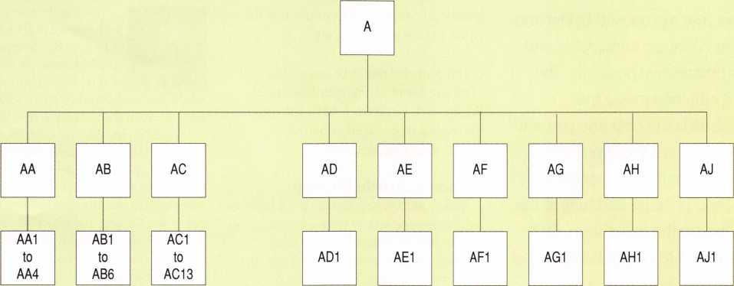

Actually needed:

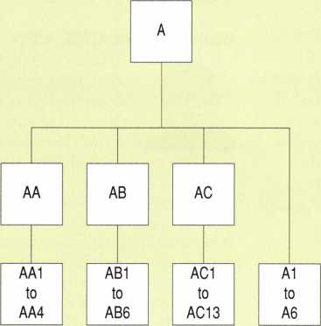

Figure 2—One of the most common mistakes is to  
waste master keys (and all the combinations under  
them) for locks that should be keyed to changes  
directly under a GMKK or GGMK.

Functions tend to remain stable in most organizations. Keying should be done by function, not personality. Bill is the warehouse manager. Bill may be a nice guy, but he’s going to give notice next Friday. Concentrate on the management of the warehouse.

Another practical approach is to present a suggested key system schematic based on your experience with similar entities, schools, small businesses, hospitals, office buildings, etc.

Also, end users have been known to complete their own hardware schedules own systems by marking site surveys with keying symbols after having the symbols explained to them.

Finally, the author has a set of worksheets called Planning for Three Levels of Keying. The work sheets can be sent to an end user or

explained to the liaison prior to the meeting. A set can be had by sending the author a #10 self-addressed, stamped envelope.

One of the most common, wasteful errors comes from confusion about change keys directly under higher level master keys. Many combinations are wasted because people ask for unnecessary master keys. See figure 2.

Remember that there are other policy questions that should be thought out. Who owns the bitting list? Is the hardware schedule generated in the site survey the property of the end user if you don’t get the job? Is the keying conference part of the cost of doing business? Experience is the best teacher. You will learn what works for you. Do a professional job and charge a professional fee.

June 1999

Keynotes

*The ALOA*

It’s election time! Here’s a review  
of this year’s proposed Bylaw and  
Article changes; candidates and  
their prospective positions. The  
ballot attached inside this  
magazine is the only one you will  
receive. To cast your vote, simply  
fill out the ballot, tape or staple it  
shut, add postage and mail to the  
address on the ballot form. DO  
NOT mail it to ALOA. Ballots must  
be received by July 8,1999.

There will be a special meeting of the  
membership at 10:00 am July 9, 1999 at  
ALOA Headquarters, 3003 Live Oak  
Street, Dallas, Texas 73204. The purpose  
of this meeting is to elect Directors and  
Officers for the association. A vote  
concerning proposed changes to  
Certificate of Incorporation and Bylaws  
will also be conducted.

The proposed Bylaws and Article Changes  
are as follows:

**PROPOSED BYLAWS AND ARTICLE CHANGES**

**Proposed Bylaws Change**

When the new ALOA Bylaws were written allocating directors to the six geographical regions, April 1 of each year was chosen as the date to use in determining the census of the regions. On this date, there are fewer members in ALOA than at any other time of the year. The Bylaws state that a membership is terminated after a member is three months in arrears of his dues. We, therefore, drop all members that have not renewed on April 1 of each year. During the remainder of the year, we continue to receive renewals and new members. July 1 will be a better date for the census because it will present a more accurate representation of the average number of members in ALOA for the year.

Article VI-Board of Directors, Section 2- Composition, third paragraph, currently reads: “The number of voting members in

22 I KeynotesJune 1999



each Region shall be determined by the  
membership census report in effect on the  
April 1 of the preceding year.”

It is proposed that it be changed to read:  
“The number of voting members in each  
Region shall be determined by the member-  
ship census report in effect on the  
July i of the preceding year.”

**Proposed Article Change**

When ALOAs new Certificate of Incorpo-  
ration was approved by the membership last  
year, it did not contain some wording  
required by the state of New York, the state  
of our incorporation. The wording is:  
“Nothing contained in this certificate shall  
authorize or empower the corporation to  
perform or engage in any act or practice  
prohibited by General Business Law, Section  
340, or any other antimonopoly or antitrust  
statute of the state of New York.”

**John J. Greenan, CIVIL, CPS**

John is the vice president  
of Fink Safe & Lock Co. in  
Chicago, IL. He represents  
the fifth generation in this  
family-owned business,

which was established in 1920. John has  
been active in the industry since 1985 and  
has served on the ALOA board for the past  
six years. He has instructed many safe-related  
classes for ALOA, Greater Chicago  
Locksmiths Association (GCLA) and several  
other associations throughout the United  
States and Canada. John is a past president of  
the GCLA. He is currently serving as  
chairman of the Allied Locksmiths for  
Illinois. John is the past chairman of the  
ALOA Legislative Committee and has served  
on several others including the ALOA  
Strategic Planning and By-Laws committees.

**N0RTHCENTRAL DIRECTOR**

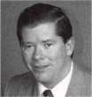

To approve the addition of the following  
paragraph to the ALOA Certificate of Incor-  
poration, following the objects and purposes,  
in paragraph “F”: “Nothing contained in  
this certificate shall authorize or empower  
the corporation to perform or engage in  
any act or practice prohibited by the  
General Business Law, Section 340, or  
other antimonopoly or antitrust statute of  
the State of New York.’ ”

**THE CANDIDATES-  
PRESIDENT**

**James H. Glazier, CML**

James H. “Jim” Glazier,  
CML has been a director for  
ALOA for the past six years  
and has also served on the  
PRP, Finance, Convention,

Education, Membership and Library/

Museum Committees. He has been in the  
security field for over 40 years, the past 19 in  
the locksmithing industry. He owns and  
operates Security Plus Locksmiths in Mount  
Airy, MD, where he specializes in closed cir-  
cuit TV, access control and high security lock  
systems. He has written numerous technical  
articles for Keynotes and was chosen as “Author  
of the Year” in 1995. He also has taught the  
instructor training classes and numerous other  
classes throughout the U.S. He is a certified  
instructor for the ACE program.

**Mark E. Blum, CML, CPS**

Mark is a 39-year  
locksmithing veteran, a  
26-year member of ALOA  
and a certified instructor for  
16 years. Mark has worked in

wholesale and retail establishments, a uni-  
versity key shop and now an independent  
general practice. He has taught at ALOA,  
local and regional locksmith associations,  
police academies, real estate seminars,  
hospital associations, insurance companies  
and neighborhood watch groups. Mark was  
the recipient of the first ALOA ACE award,  
in 1990. He currently serves as a director on  
the ALOA board.

**Tom Ripp**

A locksmith since high  
school in Waunakee, Wis.,  
Tom has been involved with  
his community’s school  
board, Land Use Planning

Commission and serves as part-time town  
constable. He worked at Best Access  
Control as an installer/ troubleshooter.

He is currently employed at University  
of Wisconsin-Madison, where he is a  
locksmith-journeyman.

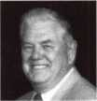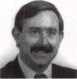

**SOUTHEAST DIRECTOR**

**James R. Bamhardt**

James has been involved  
with the locksmith industry  
for 24 years. He is a second  
generation locksmith and has  
been an ALOA member  
since 1985. He has been a

SAVTA member since 1996. He specializes  
in closed circuit TV, as well as access control  
systems. Formerly a convention volunteer in  
1998, he currently runs Economy Lock &  
Key of Brandon, Inc. in Brandon, FL.



**Donald E. Rule, CML**

Donald, an ALOA  
member since 1986, owns  
and operates Boardtown  
Locksmith. He is a past  
president and life member of  
the Louisiana-Mississippi

Locksmith Association. He is a 1989  
convention scholarship recipient and in 1996  
was appointed as a member-at-large on the  
ALOA board. He has served as a director  
since 1997. He is currently a member of the  
ALOA Legislative Action Network. Donald  
formed a member council solicited by e-mail  
for interested participants.

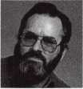

**Thomas Tate**

Thomas has been a mem-  
ber of ALOA since 1984.  
After working in Virginia  
and South Texas, he opened  
American Lock & Key in

Pensacola, Fla. He was a member of the  
now-defunct Northwest Florida Locksmith  
Association and served on the board of SER-  
LAC co-chairing the educational committee.  
He is currently the president of the Florida-  
Alabama Locksmith Association.



**SOUTHWEST DIRECTOR**

**John Ilk, CRL**

John has been a bonded member of ALOA since 1992. He is a member of the Grand Canyon Chapter of ALOA and he is presently serving as its chairman. He served as the chapter’s Education Chairman from 1994-1998. John specializes in safe deposit locks, safe combination locks and commer­cial hardware.

**Gordon Racine, CML**



Gordon has been an ALOA member since 1982 and began his career in the security industry in 1980. He’s cur­rently serving on the ALOA

Board of Directors. He owns and operates Racine’s Locksmithing & Security, one of the largest security companies in the Lajunta, CO area. He provides a security center as well as mobile locksmith and security service within a 60 mile radius of his business.

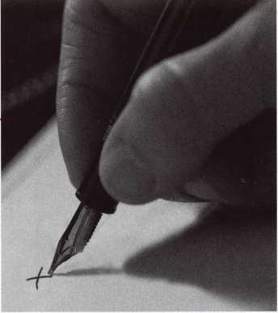

GM

10-Cut #702676

CHRYSLER

Double-Bitted

#703927

FORD

8-Cut #703373

**MITSUBISHI**1999 and Beyond  
#704605

STRAT packs.

To make sure you have all the parts you need to service your customers' locks, simply order the custom kits we call STRATpacks. All the springs, tumblers, shutters, caps, clips and retainers you need; and all OEM quality. The vast majority of vehicles made in North America come off the line with genuine STRATTEC parts - do your customers deserve any less? STRATTEC parts. The original originals.



**STRATTEC**

For more information, please call  
your STRATTEC authorized wholesale lock distributor



June 1999

Keynotes

li

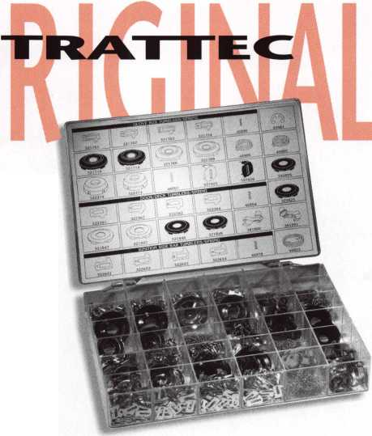

**01010010**

101(01101

*jA*

* UUft a

•‘iV

■*101010101 0101010101 M\ 10101010101011 010101010011010 10111010101010101 10101010101010011

10101010101010100

K:ey*lWcf10101

**loiotoioioioiooon**

csc^ftwavei1'

10101000101010101C

1traYnpi01oioonc

010101000101010101

1010101 Dtaiiaoioiooiioi

010101010111010101010100C

11010101

101010101

1010101010101

01010101  
I10101010

1010101011

010101010

01

sssi



Master keying is an interesting specialty of locksmithing. If you are a person who has an overwhelming phobia of math and working with numbers, setting up a master key system can be a daunting task. Manually drawing up a master key chart involves creating a list of key bittings that does not repeat any individual combination, but also covers every possibility. There is a variety of rules designed to minimize any reduction in security of the locks. When designed properly, individual change keys should operate individual locks while master keys will operate groups of locks or (in many cases) all the locks.

There is a tendency for most of us to get use to doing something the way we experience it the first time. If I hear a song and like it, it is almost impossible to listen to someone else sing the same song. Even if the next person singing the song also has a good voice, it never seems to be quite right. I have a similar attachment to the method that I first learned master keying in an ALOA- approved class (probably more than 15 years ago). Over the years, I’ve looked at a number of different master keying programs and none of them have been what I wished a computer-enhanced version of the manual method (that I learned way back then) would look like. I suppose that it must be a very complicated task to generate an on-screen master key chart that displays key bittings the way those pre-printed charts did, and at the same time allow easy manipulation of the key bitting array (KBA), sequence of progression (SOP) and the number of pin chambers to be master pinned.

But there’s more. It needs to be easy to label the change keys and display those labels on screen in the same page format with block masters, vertical and horizontal group masters, page masters and more shown on the screen. Then, it has to be able to generate pinning charts for individual change keys that I select and are listed on my master key chart.

I’m not a programmer, so I don’t know for a fact that such a computer program would be tough to create. I am making that

assumption by the fact that I have yet to see a program that does all those things. If it was a fairly simple task, I have to believe that someone would have made such a computer program by now. I have seen programs that have many of the features that I have described above, but not one that has all those features. Since I have no immediate plans to learn programming just so I can create such a program, I will have to accept the fact that I probably won’t see such a computer program in the immediate future. Then again, that is just my particular preference. Those specific features might not matter to someone else.

Data Logic has a master keying program called Master Key Plus. Along with other programs I’ve seen, it doesn’t fit the description of my wish list master keying program, but it has some of the features mentioned and some otherwise impressive features that I didn’t mention. First of all, it’s a DOS based program, but it will run in a DOS window in the Windows environment. Master Key Plus displays change key bittings in a list format.

One of four methods can be selected to generate a system. In certain situations, the computer will make most of the choices and in others, certain information can be customized. A specific lock brand needs to be chosen before starting the creation process. Certain attributes of the selected brand will be pre-determined, but can usually be modified or changed. In the “System Generation Information” screen, the program requests certain information in order to generate a master key system. The number of master key levels can be selected and you can choose how many specific master keys must be generated at each level. You can also select the number of change keys needed, and the program will determine how many pin chambers are needed to give you sufficient numbers.

Master Key Plus has some interesting specialized options. Where many master key systems will be generated with a single step or double step progression, this program will allow customized step progressions per

chamber. Conceivably, some chambers could use single step while others use double and still others use triple step progression.

Pin length can also be controlled on a chamber by chamber basis. To minimize key breakage, you might limit bottom pins in the first chamber to no longer than #7 and so on. A maximum and minimum length can be chosen for each chamber. The sequence of progressing the pin chambers can also be rearranged among other options.

You have a variety of options for how you wish to display information on screen or printed on paper. You can also get a list of pin totals, so you can determine how many of each bottom or master pins to order. There is a “Search for Key” function to find a particular key bitting on the chart. Even more interesting is a “Test Key for Fit” function which will allow you to input a key bitting and tell you what cylinders (with particular bottom and master pin arrange­ments) will work with that key. You could check to see if an old change key from a previous master key system might actually act as some level of master key in the current system and which cylinders would operate with that key.

There are other functions and features, and locksmiths looking for a master key program might want to compare this and other similar programs to see what fits their needs. For more information, contact:

DATA LOGIC

1820 Reliance Pkwy., Ste. *500 Bedford, TX 76021 Phone: 817/571-1324 FAX: 817/571-1991 e-mail: [dtlgc@flash.net](mailto:dtlgc@flash.net) Web Page: [www.dtlgc.com](http://www.dtlgc.com)

June 1999

Keynotes **125**

**Customer Access with a Twist**

**By Poul Dyson**

In today’s high tech economy, you will find a computer on the workbench beside the traditional key machine and pin kit. The necessity of a fast computer to manage key codes, generate master key systems and access product information can not be ignored in order to remain competitive.

The key to securing a reasonable profit is to make the best use of your time during the business day. It is much better to be installing product and selling new jobs rather than to be spending large amounts of time searching for information and performing clerical tasks such as ordering supplies. Equipped with the right tools for the job, a time consuming task can be reduced to mere minutes out of your busy workday. The Edi-Lock is designed for just that.

Edi-Lock is a Customer Access program available exclusively through the IDN Companies. The IDN network is spread throughout the United States and Canada, encompassing 38 distribution centers in 21 states and four Canadian provinces. IDN supplies security hardware and supplies to the locksmith trade.

Typically, you connect via modem to a terminal program with a text only type screen. In order to retrieve information, you search in the terminal screen and disconnect when you are finished. At the end of the connection, the only information you are left with is what you were able to write down while you were connected.

Edi-Lock is a Graphical Windows program containing detailed information about product items. This information is stored on your computer’s hard drive and not on a bulletin board that requires a direct connection. By having product information stored on your computer, you are able to customize these details for your company’s specific needs.

Finding product items is easy. The 10 different search methods allow you to look up products using different search criteria. Among the criteria the user can reference are manufacturer, part number, EZ #, catalog page, descriptive text and product index.

Included in the Edi-Lock program is the ability to create your own retail-selling prices

based on an acceptable mark up for your company. This can be applied for each and every product you can obtain from your IDN Company. You can further enhance these selling prices by using different mark ups for each manufacturer and by each item as well. When your cost on any of these items change, your selling prices will be automatically updated from the IDN Edi-Server.

Edi-Lock is a network compatible product allowing all the computers in your shop to share the data bases that make up the program. This means that someone can be creating a purchase order, another generating a quote for a customer and your counter PC will be retrieving prices for a walk-in customer; all at the same time. All of these activities are performed without you having to be connected to the IDN Edi-Server.

Information is added and updated on your computer when you connect to the IDN Edi- Server. You will find out about new product items as soon as they are available. When you connect to the server, you immediately retrieve your updated product costs and the manufacturers’ list prices. This means you will be selling products at the replacement value of your inventory and not at the old cost.

Edi-Lock contains a customer information screen that you may use to store Customer Information such as contact names, addresses and telephone numbers. Another feature of the program allows this information to be used for generating customer quotations.

The customer quotation module of Edi- Lock allows you a great deal of precision to rapidly create professional customer quotations. A customer quotation will contain stock items that are purchased from your IDN Company. As you add these items to the quotation, the retail-selling prices used are what you determined earlier when you set your markups in place. You may choose to modify any of the item selling prices directly, or by applying discounts on the items in the customer quotation. This customer quotation module will also accept items not stocked by your IDN Company. These custom items are created by you and may contain any products such as doors and alarm system components.

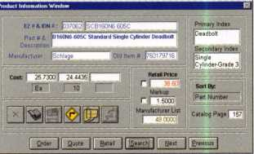

Select an Option « elk* on #» Tool Bat

No quotation would be complete without adding labor charges to it. The labor charge portion of Edi-Lock allows you to properly calculate these charges. You are able to define the labor and material component of labor charge items to arrive at a profitable selling price. Again, these items may be added to your customer quotations very easily.

Once you have created a quotation, you may print it for mailing, or fax it directly to your customer. You have the option of hiding the underlying detail of your quotation and instead present to your customer a description of the quotation with a total package price for the whole quote. Once your customer gives you the go ahead for the quotation, you may automatically add the items to a purchase order.

Ordering products using the Edi-Lock program can save you time. As you locate items, you may add them to purchase orders with a single click of the mouse. Your cost, along with available quantity breaks, will enable you to make buying decisions for the most advantageous quantity to order. It is important to note that anyone on your computer network will be able to add to the same order. Placing this order with your IDN Company electronically should in most cases take under one minute.

The owner/manager has the option of creating different user sign-ons. These sign- ons can restrict the display of your cost and mark-ups to users and lock out the ability to place orders. This feature is effective in a shop or at counter where a customer may be peering over your shoulder as you get prices for them.

For information on obtaining the Edi-Lock program for your company please contact your IDN Company or visit the Edi-Lock Internet Website at <http://edilock.com>.

MMH

HH



June 1999

h



* Super bearing construction.
* Superior rigidity and accuracy.
* Shipped with carbide cutter.
* 2 year parts and labor warranty.
* Increased cut rates:

Laser made 8 seconds.

Standard mode 12 seconds.

Bi Axial 6 pin 17 seconds.

* New Medeco Autoswing head option.

ITi«t700

coraere-

moBBa

UHlKEBO

■,030100

WEAR EYE PROTECTION

* Up to 800 built-in manufacturer depths and spaces.
* Works with most popular Master key systems.
* Serial port to communicate with user systems.
* Repeatable accuracy of l/1000th inch.
* Dependable heavy duty construction.
* 1 year parts and labor warranty.
* Cuts Medeco™ High Security keys with angled cuts.

The ITL 9000 was built by locksmiths — we know what you wanted so we built it. When a new lock comes out you add the space and depths immediately. No Mechanical adjustments. All sealed and prelubricated bearings.

CD El GOOD GDG3G9BO GDGDG9BE) □GOES EDO

Uses either 12 or 120 volts.

All manufacturer depths and spaces built in,  
Heavy duty construction.

12 month warranty.

Built in Master key System.

TOOLS LIMITED

— **Now Distributed Throughout USA, Canada & Australia** —

2639B Progressive Way • Abbotsford, BC Canada V2T6H8  
**USA:** 562-699-0060 • **Canada:** 604-852-8904 • **Canada Fax:** 604-852-8938 • **Tell Free:** 1-888-264-6627

|  |  |
| --- | --- |
| ITL *950  i □ | |
| pnasi  SUMS  EGOS]  Bid] | jgji ; \ [. ■ 1  □ 3 |

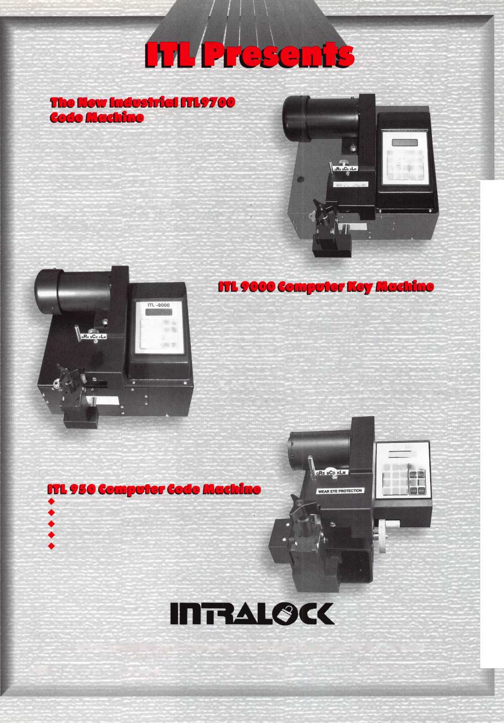

Most of the information published on master keying focuses on how to lay out the chart. Once the chart is written, it’s up to us to properly use all the combinations and give our customers the best system possible. This article will focus on how to lay out a building within the chart and how to use those ghost keys or intermediate level master keys. Let’s bring them to life as a part of the system instead of having them haunting us. Last year, I wrote a couple of articles and shared a chart with you that makes it easy to find the ghost keys.

This year, I want to redefine them and find them in a chart written in the more traditional method.

You may ask yourself, “What in the heck is a ghost key?” First, let’s look at a master keyed cylinder with two chambers master pinned the first and third.

|  |  |
| --- | --- |
| Master key | 1 6 9 4 7 |
| Change key | 3 6 5 4 7 |
| The cylinder is pinned | as follows: |
| Bottom pins | 1 6 5 4 7 |
| Master pins | 2 - 4 - - |

How many keys work this cylinder? We know at least two because we have a master and a change. What about keys cut 16547, or 36947? Both keys also work, so the answer is “four.” These additional two are considered ghost keys. Any key that operates a master keyed cylinder but is not issued as a part of the system is a ghost key. This means the moment we cut a key it’s no longer a ghost key. Adding one master pin in each chamber of a five pin cylinder means 32 different keys (2 X 2 X 2 X 2 X 2 = 32) will operate it. Adding a second master pin in each chamber increases 243 the possible keys (3 X3X3X3X3 = 243) which operate a cylinder. That’s 241 ghosts to come back and haunt you, not to mention the possibility of keys cut close which might jiggle open the cylinder. For that reason, the use of more than one master pin per chamber is bad practice and should be avoided.

**Bringing the ghosts into the living**

The first step is to develop a master key and the bitting array. The bitting array or matrix is a simple way to list all of the possible combinations of cuts available for a given master key. Using a system with cuts 0 to 9 and a two step increment generates four changes per chamber plus a master key

cut. The sequence of progression does not matter, for this example we will start with the first chamber and progress to chamber five in order. The bitting array illustrated in Figure 1 is for a master key cut 50349.

All of the possible key combinations, cutable or not, are represented within this array. Any key without cuts corresponding to the grand master is a change key. A key with one cut from the master is a first level master key. Keys cut with two, three, four, or five cuts the same are second, third, fourth, and fifth level masters. Some authors use the term “sub master” or “master,” “grand master,” etc.; but I prefer using number level since it is more descriptive. What ever you call them, they are all ghost keys until they are cut.

The first 16 changes AA1 to AA16 within this system are shown in Figure 2.

Finding the ghost keys

The first level vertical master key for changes AA1 to AA4 is 52561. Notice the first cut is the same as the grand master and the rest of the cuts are the same on every key. If only the grand master key and the change key are to be issued then this master key AA1 to AA4 would be considered a ghost key. The next 12 keys would differ from the first group with only the second chamber progressing. This uncovers a second first level master key in a horizontal direction on

the chart. Changes AA1, AA5 AA9, and AA13 are operated by a key cut 70561.

If we continue to progress the chart, then the following changes would be generated. Figure 3 includes a first level master key for each group all of which are only 1 cut different from AA1.

We now have five first level master keys identified within the system to operate AA1. These are ghost keys until they are issued. A second level master key cut 50561 has the first two cuts in common with the grand master and it fits cylinders to AA1 through AA16. Many other master keys exist, all of them are ghost keys until they are issued since they operate cylinders within the system.

Bhost keys are everywhere

Ghost keys or various level master keys exist in every group of changes on the chart. Every group of four, or power of four, has a corresponding master key or ghost key if it is not issued. Master keys or ghost keys exist in many directions on the chart, vertical, horizontal, between pages, and in an every fourth key arrangement. Each page is made up of four columns, each column four blocks and finally each block contains four changes. Figure 4 is a layout of a single page of changes, no letters precede the change key numbers since all pages use the same layout.

Figure 1

|  |  |  |  |  |  |
| --- | --- | --- | --- | --- | --- |
| Top or Grand Master | 5 | 0 | 3 | 4 | 9 |
| Change Key Array | 7 | 2 | 5 | 6 | 1 |
|  | 9 | 4 | 7 | 8 | 3 |
|  | 1 | 6 | 9 | 0 | 5 |
|  | 3 | 8 | 1 | 2 | 7 |

Figure 2

|  |  |  |  |  |
| --- | --- | --- | --- | --- |
| AA1 | 7 2 5 6 | 1 | AA9 | 7 6 5 6 1 |
| AA2 | 9 2 5 6 | 1 | AA10 | 9 6 5 6 1 |
| AA3 | 12 5 6 | 1 | AA11 | 1 6 5 6 1 |
| AA4 | 3 2 5 6 | 1 | AA12 | 3 6 5 6 1 |
| AA5 | 7 4 5 6 | 1 | AA13 | 7 8 5 6 1 |
| AA6 | 9 4 5 6 | 1 | AA14 | 9 8 5 6 1 |
| AA7 | 14 5 6 | 1 | AA15 | 1 8 5 6 1 |
| AA8 | 3 4 5 6 | 1 | AA16 | 3 8 5 6 1 |

Figure 3

|  |  |  |  |  |
| --- | --- | --- | --- | --- |
| MK 72361 | MK | 72541 | MK | 72569 |
| AA1 72561 | AA1 | 72561 | AA1 | 72561 |
| AA17 72761 | AB1 | 72581 | BA1 | 72563 |
| AA33 72961 | AC1 | 72521 | CA1 | 72565 |
| AA49 72161 | ADI | 72541 | DAI | 72567 |

Figure 4

|  |  |  |  |  |
| --- | --- | --- | --- | --- |
| MK 1-64 | MK 1-16 | MK 17-32 | MK 33-48 | MK 49-64 |
| MK 1-4, 17-21, 33-36, 49-52 | MK 1-4 | MK 17-21 | MK 33-36 | MK 49-52 |
| MK 1, 17, 33, 49 | 1 | 17 | 33 | 49 |
| MK 2, 18, 34, 50 | 2 | 18 | 34 | 50 |
| MK 3, 19, 35, 51 | 3 | 19 | 35 | 51 |
| MK 4, 20, 36, 52 | 4 | 20 | 36 | 52 |
| MK 5-8, 21-24, 37-40, 53-56 | MK 5-8 | MK 21-24 | MK 37-40 | MK 53-56 |
| MK 5, 21, 37, 53 | 5 | 21 | 37 | 53 |
| MK 6, 22, 38, 54 | 6 | 22 | 38 | 54 |
| MK 7, 23, 39, 55 | 7 | 23 | 39 | 55 |
| MK 8, 24, 40, 56 | 8 | 24 | 40 | 56 |
| MK 9-12, 25-28, 41-44, 57-60 | MK 9-12 | MK 25-28 | MK 41-44 | MK 57-60 |
| MK 9, 25, 41, 57 | 9 | 25 | 41 | 57 |
| MK 10, 26, 42, 58 | 10 | 26 | 42 | 58 |
| MK 11, 27, 43, 59 | 11 | 27 | 43 | 59 |
| MK 12, 28, 44, 60 | 12 | 28 | 44 | 60 |
| MK 13-16, 29-32, 45-48, 61-64 | MK 13-16 | MK 29-32 | MK 45-48 | MK 61-64 |
| MK 13, 29, 45, 61 | 13 | 29 | 45 | 61 |
| MK 14, 30, 46, 62 | 14 | 30 | 46 | 62 |
| MK 15, 31, 47, 63 | 15 | 31 | 47 | 63 |
| MK 16, 32, 48, 64 | 16 | 32 | 48 | 64 |
| MK 1, 5, 9, 13, 17, 21, 25, 29, | MK 1, 5 | MK 17, 21 | MK 33, 37 | MK 49, 53 |
| 33, 37, 41, 45, 49, 53, 57, 61 | 9, 13 | 25, 29 | 41, 45 | 57, 61 |
| MK 2, 6, 10, 14, 18, 22, 26, 30, | MK 2, 6, | MK 18, 22 | MK 34, 38 | MK 50, 54 |
| 34, 38, 42, 46, 50, 54, 58, 62 | 10, 14 | 26, 30 | 42, 46 | 58, 62 |
| MK 3, 7, 11, 15, 19, 23, 27, 31, | MK 3, 7, | MK 19, 23 | MK 35, 39 | MK 51, 55 |
| 35, 39, 43, 47, 51, 55, 59, 63 | 11, 15 | 27, 31 | 43, 47 | 59, 63 |
| MK 4, 8, 12, 16, 20, 24, 28, 32, | MK 4, 8, | MK 20, 24 | MK 36, 40 | MK 52, 56 |
| 36, 40, 44, 48, 52, 56, 60, 64 | 12, 16 | 28, 32 | 44, 48 | 60, 64 |

29

June 1999

Keynotes

Figure 5

GGMK

MKAA, BA,

CA, DA

MKAB, BB,

CB, DB

MK AC, BC,

1. DC

MK AD, BD,

CD, DD

MKAA*, AB*  
AC*, AD*

MK BA*, BB*,  
BC*, BD*

MK CA*, CB*  
CC*, CD*

|  |  |  |  |  |  |  |
| --- | --- | --- | --- | --- | --- | --- |
| MKA | | MKB | | MKC | | MKD |
| AA |  | BA |  | CA |  | DA |
|  | |  | |  | |  |
| AB |  | BB |  | CB |  | DB |
|  | |  | |  | |  |
| AC |  | BC |  | CC |  | DC |
|  | |  | |  | |  |
| AD |  | BD |  | CD |  | DD |

MK DA*, DB*  
DC*, DD*

MKAA*, BA*, CA*, DA*

MKAB*, BB*, CB*, DB*

MK AC*, BC*, CC*, DC*

MK AD*, BD*, CD*, DD*

Master keys or ghost keys exist between the pages again in many directions. The method shown in Figure 5 copies the 16 group arrangement illustrated in Figure 4 on a single page of the chart. The only difference is the group instead of containing four changes, contains sixty four changes. This creates many more master keys or ghost keys. To illustrate an asterisk (*) will be used to indicate either a single change or a group of four changes.

Many other master or ghost keys exist, such as the third level master key which fits the first group of four keys on each page. Once you’ve mastered (excuse the pun) this concept, you’ll find master keys at various levels through out the chart.

**Now that we’ve found them, let’s use them!**

Our customer has a small manufacturing plant with four departments. All the department heads are paranoid of each other

**f** >

EBkA/D Automotive

Automotive Locks, Keys, Service Kits, Manuals & Training  
for the Professional Locksmith

service procedures you need to succeed! VATS - PATS - GM In-Dash - and more... jAvailable only through Authorized BWD Service Manual Library Centers. See below to receive list of BWD SML Center locations.

FREE!

1999 **Illustrated Automotive Parts Catalog**

including BWD Service Manual Library Centers,Distributors,  
VATS Centers, Seminar Schedule, and more... call

**(800) 647-4926**

or take your web browser to [www.alllock.com](http://www.alllock.com).

and want to lock up their respective areas. They’re also lazy and don’t want to carry more than one key each. The owner wants unlimited access. Two of the managers, who are real paranoid have private offices that must be kept secure from their employees. Finally, everyone’s keys must fit the front door. Using the system created above here is how to do it.

OWNER

Grand Master Key

ACCOUNTING MANAGER

Second Level Master Key AA1 to AAl 6

Office Door Key AA6

ACCOUNTING CLERKS

First Level Master Key AAl to AA4

Department Door Keys AA2

MAINTENANCE MANAGER

Second Level Master Key AAl, AA5, AA9, AAl3; AAl7,

AA21, AA25, AA29; AA33, AA37,  
AA41, AA45; AA49, AA53, AA57, AA61  
Office Door Key AA37

MAINTENANCE DEPARTMENT

First Level Master Key AAl, AAl7, AA33, AA49

Department Door Key AA33

PRODUCTION MANAGER/DEPARTMENT

First Level Master Key AAl, ABl, ACl, & ADI

Department Door Key ABl

SALES MANAGER/DEPARTMENT

First Level Master Key AAl, BAI, CAI, & DAI

Department Door Key BAI

FRONT DOOR AAl

50349

5056 1 7456 1

5256 1 9256 1

7036 1 7496 1

7236 1 7276 1

72 54 1 72582

72569

72563

7256 1

Some of you might think this is a lot of work to go through just to provide a system to the customer. A few of you might prefer to leave a couple of chambers empty or stack some master wafers into the cylinder to provide the kind of system I’ve described. The problem with this is should they be broken into with no signs of forced entry, you could be held liable for poor master keying skills. Once you get used to thinking of using intermediate level master keys to provide the convenience of your customers only having to carry one key you'll sleep better at night knowing those ghost keys are alive and working for you instead of against you.

***Keynotes***

June 1999

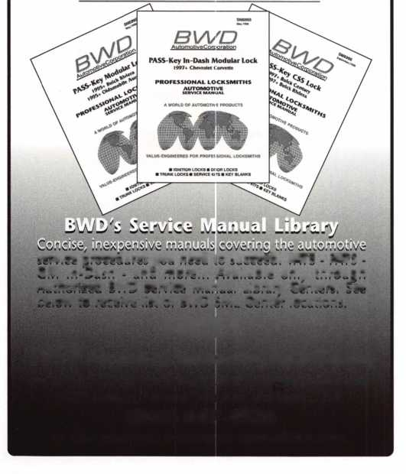

and you can throw away the key.

When a New York City area locksmith broke the law, Medeco took him to court. Anyone who tries to  
compromise Medeco’s patented key control systems is compromising the business of legitimate Medeco  
dealers. Customers rely on the expertise of Medeco locksmiths and our exclusive patented locks and keys.  
That’s why we protect our key control. Because it protects locksmiths and consumers.

Medeco high security products are only available  
through authorized Medeco dealers. We’re a company  
that stands by our products, our dealers, and their  
customers. And when it comes to high security,  
we have very strong convictions.

medeco

HIGH SECURITY LOCKS

3625 Allegheny Drive, P.O. Box 3075, Salem, Virginia 24153-0330

An ASSA ABLOY Group company

THERE ARE 50 -REASONS WHY YOU SHOULV JOIN US THIS YEAR



THE FIRST 49 ARE ALREADY OVER. DON’T MISS THIS ONE!

GPL A 50th Anniversary Convention

September 15th-19th, 1999  
Radisson Philadelphia International Airport

Free Clinic Product Exhibit

Key Squares Breakfast Lock Picking Contest

Hands-on Training Classes Black Tie Awards Banquet

President’s Reception Friday Night Social

For Further Information:

Reservations Exhibitors

Jack Magee Don Amole

Phone: 609-384-1538 Phone: 215-288-5588

Fax: 609-845-3024 Fax: 215-288-2511

Or visit our website at: [www.gpla.org](http://www.gpla.org)

**THE SOURCE FOR...**

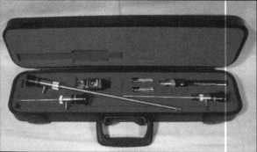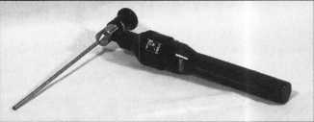

**Hawkeye... Karl Storz**

**two of the finest names in borescopes**

**German optics** plus **quality construction** plus **a wide range of sizes  
equals Storz, the leader in industrial visual inspection products.**

**See the quality for yourself.**

**Offering the best products at the best**

**prices makes Timemaster your source for your every day “safe tech”**

**needs. Call today for our inventory and pricing.**

Second Quarter Specials

Complete Hawkeye Kit: fiberoptic straight view probe, 90° mirror tube, light handle,  
carrying case, cleaning kit 7" kit was $590.00 NOW $520.00

12” kit was $690.00 NOW $608.00 17" kit was $760.00 NOW $670.00

**Time-Master.com (web) • [TIMSTR@aol.com](mailto:TIMSTR@aol.com) (email)**

IM E 888 798 8464 / Fax 800 798 TIME (8463) • 785 232 8705 / Fax 785 232 2603

**ASTER Canada Sales Office: David Bickers** 6049447129 **/ Fax** 6049447248

|  |  |
| --- | --- |
| > |  |
| Q | P |

Keynotes

June 1999



(Editor’s note: This is the first in an installment of locksmithing hook reviews. If you’re an author or publisher and want to see your hook reviewed, contact us at Keynotes, 3003 Live Oak, Dallas, TX 75204.)

As locksmiths, we are trained by our peers, educated through correspondence schools and given hands on instructions at several excellent technical schools throughout our country. One of the best forms of educating ourselves is through reading.

Unfortunately, however, there are not as many books that are updated in information, in print or available for purchase. So, we locksmiths must continue to seek out those books that will allow us to acquire additional educational knowledge. This will serve to encourage our continued growth and professional stature in the business world today.

Keynotes will begin an ongoing series of book reviews of those books currently in print and available for purchase by the locksmith today.

The first book well look at is The Complete Book of Locks and Locksmithing by Bill Phillips published by McGraw-Hill in 1995.

Phillips is a licensed locksmith and wrote The Complete Book of Locks and Locksmithing in 1976. The book is currently in the fourth edition and contains 483 pages of information about locks and lock­smithing techniques. This book is currently in print and can be ordered and purchased at a cost of $ 27.95.

In his book, Phillips lists 21 chapters of information that are helpful to someone interested in acquiring information about locks and locksmithing. These include “The History of Locks and Lock­smithing,” “Tools of the Trade,” “Types of Locks and Keys and Home and Business Services.”

Many of these chapters contain very basic information, detailing types of locks, keys and tools needed on rudimentary locksmithing tasks. While some this information is helpful, many chapters are shallow and do not fully explain very basic and simple locksmithing practices and techniques.

An example would be Chapter 11, Buying and Selling Safes. Although informative, it does not cover the basic applications used in changing combinations, opening techniques, servicing and repairing safes. Chapter 16 covers Automobile Locks and consists of a mere six pages of information. Again, these methods identified do not cover basic keying applications or lock and cylinder removal. Plus, they lack basic technical information in this field.

In Chapter 17, the emergency entry tools listed are outdated and in some instance dangerous to use on any automobile. This chapter could have been expanded to include the number of excellent car opening tools and reference materials available for purchase and use at

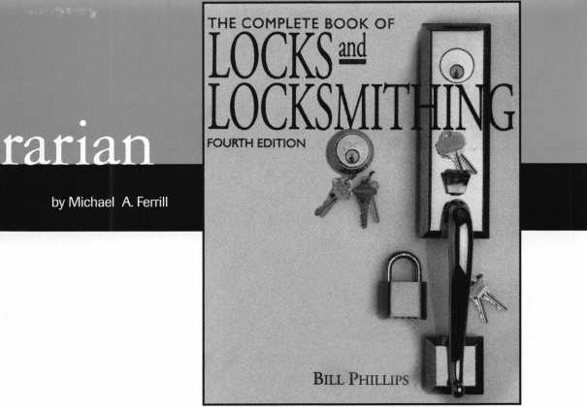

the time of this publication. This would have indeed helped the beginning locksmith, in car opening techniques.

Chapter 20 and 21 cover basic information about the business of locksmithing and key duplicating machines. Although informative, they display several outdated advertising signs, key racks and color key carousels. The key cutting machines identified are very simple machines. Basic business practices in advertising and selling to the residential and commercial customer could have been written explaining simple marketing and business strategies. Forms and recommended uses of such would have been a plus, and a well thought out business plan would have helped the beginning locksmith in his start up business effort.

The photographs and graphics used within the content of the book are very helpful and will provide additional technical information to the locksmith. However there are a number of photographs and graphics that are outdated and should no longer be used to teach or explain locksmithing techniques.

The book itself is not overly technical and is very basic in its appli­cation of standard locksmithing practices. It can be easily read by the average student or reader interested in this subject.

The book mentions that it is the world s best-selling locksmithing book, and is used as a textbook and reference source by more students, apprentices, and professional locksmiths than any other book on the subject. I must admit that it could be used by a number of locksmithing schools as a basic resource guide to complement their class room instruc­tions. A number of schools currently teaching locksmithing courses today were contacted by this writer and I was informed by a number of these schools that they simply do not use this book or reference it in any form. As to the expression of best selling locksmithing book, that could be a tme statement. McGraw and Hill Publishers are world famous for promoting “How To” books in the technical and trade school subjects. Any book properly promoted will sell.

There are very few locksmith books in publication today that are in print and available for purchase. The fact that this book is even available is a plus, and should be added to your library.

I would recommend the purchase of this book as a basic resource guide to enhance your existing technical and trade school publications. The cost of the book is reasonable. I look forward to Mr. Phillips’ publi­cation of his fifth edition in the future. It would be appreciated by me, as a writer and reader, if it updated photographs used within the content of the book, contained better graphics and listed current information in the appendix. An additional listing of available locksmithing schools (corre­spondence and resident schools), would be helpful for the average reader considering pursuing a career in the field of locksmithing.

u

June 1999

Keynotes



4

Keynotes

Classified



Dept

**Classified Advertising Policy**

**r Classified advertising space is provided free of charge to ALOA members, and for a fee of $.60 per word, $15 minimum for non-members. Classified ads may be used to advertise used merchandise and overstocked items for sale, “wanted to buy” items, business opportunities, employment opportunities/positions wanted and the like. Members or non-members wishing to advertise services or new merchandise for sale may purchase a “Commercial Classified Ad,” for a fee of $U0 per word, with a minimum of $40. Each ad will run for two issues. For blind boxes there is a $5 charge to members and non-members. All ads must be submitted in writing to the ALOA office by the Fifteenth of the month, two months prior to issue date. Send to Keynotes Classifieds, 3003 Live Oak SL, Dallas TX 75204-6T86. ALOA reserves the right to refuse any classified advertisement that it deems inappropriate according to the stated purpose of the classified advertising section.**

■ EMPLOYMENT Lock/Safe Technician

6/F/3: Canadas national safe and lock company requires a Service Technician. Located in Calgary, Alberta, Canada, you will provide service and maintenance to our clients’ physical security equipment. Experience with safes and/or locks is advantageous, but we are willing to invest in the training of a suitable candidate with mechanical ability and/ or aptitude. We offer a competitive salary and benefits package. Please mail or fax your resume to:

John Haining-Regional Manager Chubb Lock & Safe #8, 5708-1st Street SE Calgary, AB T2H 2W9 Canada (403) 255-2222 (403) 258-1702 fax

Experienced Technicians Wanted

6/F/3: Family owned business since 1911, serving Knoxville and surrounding areas in East Tennessee are in need of experienced commercial, industrial and residential technicians. Must supply background check, work and personal references. Must have a clean driving record, no felonies, able to be a team player, neat, honest and good communication skills. Monday through Friday 8 a.m. to 3 p.m. Guaranteed salaries with monthly and yearly bonuses. Insurance and prescription cards for employee and family, retirement after 90-day trial, paid vacation and sick pay after one year. Salary is negotiable. Send resume and cover letter to: William M. Peters Jr., CRL The F.M. George Safe & Lock Company Inc.

P.0. Box 3398 Knoxville, TN 37927-3398

Locksmith Needed

6/F/3: Immediate openings, Outside Technicians and Inside Technicians in Oxnard, Calif. Benefits plus salary, close to the beach, excellent weather. Fax resume to: Nasons’s Lock & Safe Inc.

(805) 487-8280fax

Salesperson Needed

6/F/3: Wholesale Distributor Seeking Inside Salesperson for its Dallas, Texas Distribution Center. Full Benefits including 40IK Retirement Plan. Send resume to:

Accountants Office 6517 Hillcrest, Suite #308 Dallas, TX 75205

Lock & Safe Technicians Needed

5/F/3: King Safe & Lock in Houston is looking to hire experienced and trainee locksmiths. Positions available for dispatcher, inside/outside/sales technician. Established 25 year old company with heavy commercial customer base, servicing architectural door hardware, safes/vaults, master-keying and access control. We offer training to qualified applicants who wish to “earn while learning,” to be a professional locksmith. Experienced lock technicians are paid top wages with a benefit package. Medical/ Dental insurance, retirement plan, uniforms, commissions, tmcks furnished and professional advanced training. All applicants handled in confidence, private appointments are available. Please send a resume with a recent photo to:

KSL Inc.

8429 Katy Freeway Houston, TX 77024 (800) KINGL0K (713) 465-0824 Fax

kinglok@kinglok. com

Commercial Locksmith Wanted

5F/3: Located in the middle of God’s country, Charlotte, N.C. We’re a growing progressive, ethical, established and well financed 29 year old, second generation distributor of hollow metal, wood doors and finish hardware.

We’re seeking a Locksmith/Key Records Manager. Individual shall be professional, organized, familiar with different commercial lock manufacturers’ products and capable of generating Key Systems and Key Schedules according to industry standards. AHC or CML preferred but not required. Competitive salary with bonuses, medical insurance, 401K, profit sharing and relocation assistance. Send resume with requirements in confidence to:

Mark S. Burgess, AHC Burgess Sales & Supply, Inc.

2121 West Morehead Street Charlotte, NC 28208 (704) 333-8933 (704) 333-6521 fax

Experienced Locksmith Looking For Position

6/F/3: Downsizing is taking its toll. Locksmith with 20 years of experience is looking for a position in the Dallas/Ft. Worth area. I am experienced in Commercial, Retail, Residential and Corporate locksmithing. I have certification in ASSA, VonDuprin Schlage and many other high security systems. Other experience includes Safe work, stand alone access control systems, masterkeying, lockshop management, purchasing and inventory. I have a lot to offer. Looking for a company I can retire with. I prefer to stay in the Dallas/Ft.Worth area, but relocation is negotiable. If interested, direct all inquiries to:

Keynotes Classifieds 3003 Live Oak Street Dallas, TX 75204 (214)827-1701 (214) 827-1810fax

Locksmith Wanted

5/F/3: California I30-60K plus benefits. Two years experience minimum. Send or fax resume to:

Speedy Locksmiths Inc.

2517 N. Main Street Walnut Creek, CA 94596 (925) 933-9010 (925) 280-7274 fax

■ BUSINESSES FOR SALE Business For Sale

6/F/3: Well established business mostly commercial and government accounts, plus residential and automotive. Located in a growing community in northeast Dakota. Gross 118K, price includes inventory, tools computerized codes and MasterKey systems. 95 Ford Aerostar Van, fully equipped. Owner planning to relocate. Call:

(701) 775-6993

Keynotes

June 1999

Business For Sale

5/F/3: Trenton-Princeton, NJ. Rt. 1 Corridor. Gross 175K, two person.

Locks, alarms, showroom, two vans with great potential. $185K with real estate, but will separate. Contact Jim Blake or fax your bid to:

Jim Blake

Blakes Locksmiths Security Inc.

1664 East State Street Trenton, NJ 08609 (800) 228-1268 (609) 586-2716 fax

Business For Sale

5/F/3: Well established locksmith business, with many commercial and industrial accounts make this a very successful operation. Established in 1986, we have continued to grow reaching a $135K plus gross. Located in south-central North Carolina near good fishing, hunting and recreational areas. This community is growing, with a very strong base of banking, large office complexes, myriad of industrial sites and a state university. Our service area includes the surrounding counties. This is a great opportunity for the right “Go-Getter,” as instant growth is possible by adding residential and automotive service to our established commercial client base. Owner wants to retire but will stay on to smooth the transition. Price includes 1995 Dodge Maxievan-fully equipped and has 4K Onan genset and 1 IK BTU roof air, as well as all office equipment, including several computers. Asking $150K. Serious inquiry only-please. Contact:

Ray R Whitehead, CML American Safe & Lock 8501 Cedarbrook Drive Charlotte, NC 28215 (704) 563-9067 (704) 563-0134 fax

■ WANTED TO BUY/SELL Time Lock Specialist

6/P/2: Used safes, all sizes: A-B-C, U.L.

Fire Rated, Iron Safes, Tellers, Lockers and Vault doors. Call:

Monroe

Empire Safe Company (800)543-5412 (212) 684-5550 fax

Misc. Items for Sale

6/F/3: 457 Magnum with magnets and case, various older safe locks, wheel packs nests, 3-wheel, 4-wheel, 5-wheel, OB2, Emperor, HHH, Debrid, etc. Old Safe Deposit Locks-3300, 3311, etc. 30 Lock nest with keys. Will trade all or part. Call for prices: Dan Blackwood (208) 847-1999

HPC Code Punch Machine For Sale

6/F/3: HPC Code Punch Machine with Punches: PCH 1011, PCH 1014 and PCH 14. Accessories include: 79 code card/ 4 micro-meter cards, HPC Depth and Spacing book, Allen Wrench, Punch Die Wrench, Depth Adjustment Wrench, Manual and Carrying Case. $750 OBO. Serious Inquiries Only. Contact:

13610 Langtree Lane Woodbridge, VA 22193 (703) 897-0360

Web Site for Locksmiths and Safetechs

6/P/2: See the new web site <http://www.usalocksmith.com> For all Locksmiths and Safetechs. Password is “locksafe” lowercase. In the Locksmith forum post tips tricks, questions, seek, sell, etc. All for free. Other areas offer more exposure. You can advertise products, your business. Contact:

Larry Schamberger

(303) 458-1096 webmaster@usalocksmith. com

Keys for Sale

5/F/3: 700 pair pre-cut Schlage original keys. Best offer.

Call: (215) 331-3286

Locksmith Tools and More For Sale

5/P/2: Locksmith tools, supplies, machines, two Curtis Automotive Code Cutters, Code books and safe tools. Depth key sets and over 5,000 automotive and domestic keys. $18,500 firm.

Contact: John M. Merry P.O. Box 728 Dereby, NY 14047-0728 (716) 549-5439

Time Lock Specialist

5/P/2: Experienced Safe and Lock Technician servicing all makes and models of time locks since 1983. Go after that business you’ve had to shy away from. You pull and ship the clock, we repair/service it and ship it back for you to re-install.

Contact: The Clockworks (562) 690-9967

Chicago Lock Wanted

5/F/3: Looking for Chicago Lock #42l4A, double-prong Ace desk type lock, used on police call boxes. Requesting quantity and price.

Call: E. Kostelaz (Gene)

(806) 352-2157

Reed Code Books Wanted

5/F/3: Locksmith looking for Reed code books. Have some volumes, but looking for others.

Contact: August Gomes Gus The Locksmith P 0. Box 1219 West Warwick, RI 02893 (401) 821-1834 [LOCK5MlTH@aol.com](mailto:LOCK5MlTH@aol.com)

ALOA HAS  
FAK ON  
DEMAND!

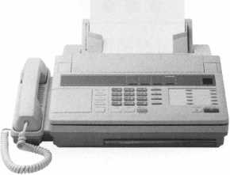

NEED INFORMATION  
IN A HORRY?

Just call 310.575.5074  
and you will be faxed:

#1 A list of all documents available through this service #2 Becoming A Locksmith #3 Locksmith Career Summary #4 Locksmith School List #5 ACE Class Schedule #6 Certification Information #7 PRP Category List #8 ALOA Membership Application #9 ALOA List of Benefits #10 Scholarship Application Form #11 ALOA Video Library Order Form #12 ALOA Membership Items Order Form #13 Safe & Vault Technicians Association Member Application/Subscription Form #14 ALOA Chapter Roster #15 Legislative Action Network #16 Legislative Action Network Newsletters #17 Various State Laws #18 Industry Position Paper

YOUR ASSOCIATION  
CONTINUES TO EXPLORE  
WAYS TO PROVIDE YOU,  
OUR MEMBERS,  
WITH NEW BENEFITS  
AND SERVICES.

June 1999 Keynotes L_

**Associate**

Members



|  |  |
| --- | --- |
|  | Arrow Lock Company  10300 Foster Avenue  Brooklyn, NY 11236 (718) 257-4700; FAX (718) 649-9097 |
|  | • see |
| A & B Safe Corp.  171 S. Delsea Dr.  Glassboro, NJ 08028 (800) 253-1267; FAX (609) 863-1208 | Auto Security Products (A. S. P.)  P.0. Box 10  Redmond, WA 98073-0010 (425) 556-1900; FAX (425) 558-1205 |
| • • • • | • • |
| ASSA Inc.  10300 Foster Ave.  Brooklyn, NV 11236 (800) 235-7482; FAX (718) 257-2772 | BWD Automotive  900 Ravenwood Dr.  Selma, AL 36701  (334) 874-9001; FAX (334) 874-6011 |
| • | • • |
| Abus Lock Company  3555 Holly Lane North  Plymouth, MN 55447-0507 (800) 352-2287; FAX (612) 509-9939 | Chicago Lock Company  10100 88th Ave.  Pleasant Prairie, Wl 53158-0069 (800) 445-3204; FAX (414) 947-7178 |
| • | • |
| Adams Rite Manufacturing Co.  P.0. Box 1301  LaPuente.CA 91749-1301 (562)699-0511; FAX (562) 699-5094 | Corbin Russwin Architectural Hardware  P.O. Box 25288  Charlotte, NC 28229 (800) 543-3658; FAX (800) 447-6714 |
| • • • • | • 9 9 9 |
| Adesco Safe Manufacturing Co.  web: [www.adesco.com](http://www.adesco.com) email; [sales@adesco.com](mailto:sales@adesco.com) (800) 821-6803; FAX (562) 408-6427 | Curtis Industries  6140 Parkland Blvd, Ste. 300  Mayfield Heights, OH 44124-4103 (800) 555-5397 |
| • | • 9 |
| Adrian Steel Company  web: [www.adriansteel.com](http://www.adriansteel.com)  Adrian, Ml 49221  (800) 677-2726; FAX (517) 265-5834 | DETEX  302 Detex Dr.  New Braunfels, TX 78130 (800) 729-3839; FAX (830) 620-6711 |
| • | 9 9 9 9 |
| Alarm Lock Systems, Inc.  345 Bayview Ave.  Amityville, NY 11701 (800) ALA-LOCK; (516) 789-3383 | Don-Jo Manufacturing, Inc.  P.O. Box 929  Sterling, MA 01564 (508)422-3377; FAX (508) 422-3467 |
| • | • 9 |
| Aiphone Intercom Systems  1700-130th Avenue, NE  Bellevue, WA 98005 (425) 455-0510; FAX (425) 455-0071 | Door Controls International  2362 Bishop Circle East  Dexter, Ml 48130  (800)742-3634; FAX (800) 742-0410 |
| • • • | • 9 9 9 |
| American Lock Co.  3400 West Exchange Road  Crete, IL 60417-2099 (708) 534-2000; FAX (708) 534-0531 | ESP Lock Products, Inc.  375 Harvard Street  Leominster, MA 01453 (978) 537-6121; FAX (978) 534-9109 |
| • • | 9 9 |
| American Security Products (AMSEC)  11925 Pacific Ave.  Fontana, CA 92337-6963 (800) 423-1881; FAX (909)685-9685 | Folger Adam Security, Inc.  16300 W. 103rd Street  Lemont, IL 60439  (630) 739-3900; FAX (630) 739-6138 |
| 9 9 | 9 9 |
|  |  |

Associate members of the Associated Locksmiths of America (ALOA) manufacture or distribute materials or equipment, or provide services, for the security industry. Many have donated money, services and equipment to ALO A in addition to their annual dues. Their support of ALOA projects enhances overall membership benefits and we encourage our members to patronize these firms. If you know of a potential candidate for associate membership, please contact the ALOA Membership staff at (800) 532-ALOA. Associate member dues are $500 per year and entide the payor to use the ALOA logo, and selected discounts on ALOA products and services.

Legend

9 A**la**r**ms:** Personal, vehicle, electronic, fire, burglar, and exit

9 Automotive: Lockout equipment, key chains/rings

**9** Builders Hardware: Door closers, furniture/decorative hardware, viewers, emergency exit devices

Books, reference guides, publications, computer software

**9** CCTV/Photo Imaging: Cameras, monitors, photo ID equipment, cables

e Electric/Electronic Security: Card access control and readers, surveil­lance, electric/magnetic locks and strikes, keypads

**9** Lock Devices: Auto locks, cylinders, emergency exit/entrance control, locks (various types), strikes

® Tools A Supplies: Key blanks, cutters, picks, rings/hooks, custom van/truck supplies



***Keynotes***

June 1999

|  |  |  |
| --- | --- | --- |
| Fort Lock Corp.  3000 N. River Rd.  River Grove, IL 60171 (708) 456-1100; FAX C708) 456-9476 | La Gaud, Inc.  3330 Kashiwa Street  Torrance, CA 90505 (310) 325-5670; FAX (310) 325-5615 | Sargent & Greenleaf, Inc.  P.O. Box 930  Nicholasville, KY 40340-0930 (606) 885-9411; FAX (606) 887-2057 |
| • ••••• | • • • | • • • • |
| Grobet File Co. of America  750 Washington Ave.  Carlstadt, NJ 07072 (800) 962-7242; FAX (800) 243-2432 | Lucky Line Products  7890 Dunbrook Rd.  San Diego, CA 92126 (619) 549-6699; FAX (619) 549-0949 | Schlage Lock Co.  1915 Jamboree Suite 165  Colorado Springs, CO 80920 (800) 847-1864; FAX (800) 452-0663 |
| i | 0 | • • |
| H.E.S., Inc.  2040 W. Quail Ave.  Phoenix, AZ 85027 (602) 582-4626; FAX (602) 582-4641 | M.A.G. Engineering & Mfg. Inc.  15261 Transistor Lane  Huntington Beach, CA 92649 (714) 891-5100; FAX (714) 892-6845 | Schwab Corporation  110 Professional Court  Lafayette, IN 47905 (765) 447-9470; FAX (765) 447-8278 |
| • • • | • • • | • |
| HPC, Inc.  3999 N. 25th Avenue  Schiller Park, IL 60176 (847) 671-6280; FAX (847) 671-6343 | MARKS USA  5300 New Horizons Blvd.  Amityville, NY 11701 (516) 225-5400; FAX (516) 225-6136 | Securitron Magnalock Corp.  550 Vista Blvd.  Sparks, NV 89434  (800) 624-5625; FAX (702) 355-5636 |
| • it | • | • • |
| HID Corporation  9292 Jeronimo Road  Irvine, CA 92618  (949) 568-1600; FAX (949) 568-1680 | MUL-T-LOCK USA, Inc.  300-1 Route 17 South Suite A  Lodi, NJ 07644  (800) 562-3511; FAX (973) 778-4007 | Security Door Controls  3580 Willow Lane  Westlake Village, CA 91361 (805) 494-0622; FAX (800) 959-4732 |
| • • | • • • | • |
| llco Unican  400 Jeffreys Road  Rocky Mount NC 27804 (252) 446-3321; FAX (252) 446-4702 | Master Lock Company  2600 North 32nd Street  Milwaukee, Wl 53211 (414) 444-2800; FAX (414) 449-3114 | Security Solutions  1640 W. Hwy. 152  Mustang, OK 73064 (405) 376-1600; FAX (405) 376-6870 |
| ••••••• | • • | • 0 • |
| In Out Systems, Inc.  3650-B Matte Boulevard  Brassard, Quebec J4Y-2Z2, Canada (450) 444-5949; FAX (450) 444-4856 | Medeco Security Locks  P.O. Box 3075  Salem, VA 24153  (540)380-5000; FAX (540) 380-5010 | Sentry Group  900 Linden Ave.  Rochester, NY 14625-2784 (716) 381-4900; FAX (716) 381-8559 |
| • • | • • • | • |
| Intellikey  551 S. Apolo Boulevard, Suite 204  Melbourne, Florida 32901 (800) 226-0703; FAX (407) 724-0811 | Meilink Safe Company  111 Security Parkway  New Albany, IN 47150 (800) 634-5465; FAX (800) 896-6606 | Sully Tools Inc.  3515 Nodding Pine Ct  Fairfax, VA 22033  (703) 689-3416; FAX (703) 787-0869 |
|  | • | • • • |
| KABA High Security Locks  P.O. Box 490  Southington, CT 06489 (860) 621-3601; FAX (860) 621-9727 | National Cabinet Lock  200 Old Mill Road, P. 0. Box 200  Mauldin, SC 29662 (864) 297-6655; FAX (864) 297-9987 | Taymor Industries, Inc.  1586 Zephyr Ave.  Hayward, CA 94544 (800) 388-9887; FAX (800) 288-8133 |
| • | • | • 0 |
| KEY-BAK; Div. of W. Coast Chain Mfg. Co.  1460 S. Balboa Ave.  Ontario, CA 91762 (909) 923-7800; FAX (909) 923-0024 | Newman Tonks  805 N Buckman St  Shepardsville, KY 40165 (800) 826-5792; FAX (800) 777-8229 | Trine Products Corporation  1430 Ferris Place  Bronx, NY 10461  (718) 829-4796; FAX (718) 792-9127 |
| • • • • | • • | • • • |
| Knaack Manufacturing Co.  420 E. Terra Cotta Ave.  Crystal Lake, IL 60014 (800) 456-7865; FAX (815) 459-9097 | ROFU International Corp.  2004-B 48th Ave.; Court E  Tacoma, WA 98424 (800) 255-7638; FAX (253) 922-1728 | Videx, Inc.  1105 NE Circle Blvd.  Corvallis, OR 97330 (541) 758-0521; FAX (541) 752-5285 |
| • | • • • | • 0 • |
| LAB Security  700 Emmett St.  Bristol, CT 06010  (800) 243-8242; FAX (203) 583-7838 | Rutherford Controls Inc.  2697 International Pkwy, Bid 5 #100  Virginia Beach, VA 23452 (757) 427-1230; FAX (757) 427-9549 | W-Lok Corporation  675 East 16th Street Suite 111  Holland, Ml 49423 (616) 355-4015; FAX (616) 355-4295 |
| • | • | 0 |
| LCN Closers (Division of Ingersol)  121 W. Railroad Ave.  Princeton, IL 61356 (815) 875-3311; FAX (815) 875-3222 | STRATTEC Security Corp.  3333 W. Good Hope Rd.  Milwaukee, Wl 53209 (414) 247-3333; FAX (414) 247-3329 | Weiser Lock Company  6700 Weiser Lock Blvd.  Tucson, AZ 85746  (502) 741-6338; FAX (520) 741-6363 |
| • | • • • | 0 0 |
|  |  |  |

June 1999

***Keynotes***

37

|  |  |  |
| --- | --- | --- |
| Yale Security Inc.  P.O. Box 25288  Charlotte, NC 28229-8010 (800] 438-1951; FAX (800] 338-0965  • • • • | Dire’s Lock & Key Co.  2201 Broadway  Denver, CO 80205  (303) 294-0176; FAX (303) 294-0198 | Hardware Suppliers of America  P.O. Box 2208  Winterville, NC 28590 (800) 334-5625; FAX (800) 334-5635  ® • |
| Zhongshan Hua Feng Lock Products  S Yongning Industrial Road, Ziaolan Zhongshan Guangdong, China  86-760 227 82 63; FAX 86-270 227 80 63  m | Direct Security Supply, Inc.  36 Lincoln Street  Boston, MA 02135 (800) 252-5757; FAX (800) 452-8600  ^ (0) @ (0) Q <j^ ^ | IDN, Inc.  1000 S. Main, Suite 280  Grapevine, TX 76051 (817)421-5470; FAX (817) 421-5468 |
| EEBsGcrBCbcioQcDcrs | Doyle Lock Supply  2211 W. River Road N.  Minneapolis, MN 55411 (800) 333-6953; FAX (612) 521-0166 | Intermountain Lock & Supply Co  3106 South Main Street  Salt Lake City, Utah 84115 (800) 453-5386; FAX (801) 485-7205  •••••••••• |
| Accredited Lock Supply Co.  P.O. Box 1442  Secaucus, NJ 07096-1442 (800) 652-2835; FAX (201) 865-5031  • •••••• | Dugmore & Duncan Inc.  30 Pond Park Rd.  Hingham, MA 02043 (888) 384-6673; FAX (888) 329-3846  ^ (p ($ ^ | JLM Wholesale, Inc.  3095 Mullins Ct  Oxford, Ml 48371-1643 (800) 522-2940; FAX (800) 782-1160  • • • |
| Ace Lock & Security Supply Co.  565 Rahway Ave.  Union, NJ 07083-6631 (800) ACE-LOCK; (800) ACE-FAX4  •••••••• | E. L. Reinhardt Co., Inc.  3250 Fanum Road  Vadnais Heights, MN 55110 (800) 328-1311; FAX (612) 481-0166  •sees® | Jo-Van Distributors Inc.  929 Warden Ave.  Scarborough, Ontario MIL 4C6 (416) 752-7249; FAX (416) 752-3845  ••••••••••• |
| Akron Hardware Consultants, Inc.  2579 South Arlington Road  Akron, OH 44319  (800) 321-9602; FAX (800) 328-6070  ^ | Ewert Wholesale Hardware  4709 W 120th St  Alsip II 60658  (800) 451-0200; FAX (708) 597-0881  • • • • • | Lockmasters, Inc.  5085 Danville Road  Nicholasville KY, 40356 (800) 654-0637; FAX (606) 885-7093  • • • • |
| American Security Distribution  4411 E. La Palma  Anaheim, CA 92807 (714)996-0791; FAX (714) 579-3508  ^ ^ (Q <£) ($ ^ | Fairway Supply, Inc.  2631 Lombardy Lane  Dallas, TX 75220  (214) 350-0021; FAX (214) 352-4299  (gj> @ (0 (Q 0 | Locks Company  2050 N.E. 151 St.  N. Miami, FL 33162 (800)288-0801; FAX (305) 949-3619  @ (0 |
| Andrews Wholesale Lock Supply  544 S. 9th St.  Lebanon, PA 17042-6608 (717) 272-7422; FAX (717) 274-8679  • | Foley-Belsaw Company  6301 Equitable Road  Kansas City, MO 64120 (800) 821-3452; FAX (816) 483-5010  ^ | The Locksmith Store Inc.  1229 E Algonquin Rd. Suite E  Arlington Heights, IL 60005 (847) 364-5111; FAX (847) 364-5125  • • • • |
| Boyle & Chase Inc.  P. 0. Box 74  Accord, MA 02018-0074 (800) 325-2530; FAX (800) 205-3500  • • • | Fried Brothers, Inc.  467 N. 7th St.  Philadelphia, PA 19123 (800) 523-2924; FAX (800) 541-3489 | M. Zion Company  69 Reade Street, 4th Floor  New York, NY 10007 (212) 349-8677; FAX (212) 964-0495  ••••••• |
| Clark Security Products, Inc.  4775 Viewridge Ave.  San Diego, CA 92123-1641 (800) 854-2088; FAX (619) 974-5284 | HS&S Wholesale Distributors  12915 West 8 Mile Road  Detroit Ml 48235  (800) 521-2202; FAX (313) 342-7580  @ <|^ (Q (j^ ^ | McDonald-DASH Locksmith Supply  5767 E. Shelby Dr.  Memphis, TN 38141 (800) 238-7541; FAX (901) 366-0005 |
| Cook’s Building Specialties  2441 Menaul Blvd. NE; P.O. Box 37320 Albuquerque, NM 87176-7320 (505)883-5701; FAX (505) 883-5704  •••••• | Hans Johnsen Company  8901 Chancellor Row  Dallas, TX 75247  (214) 879-1550; FAX (214) 879-1530  •••••••• | McManus Locksmith Supply, Inc.  P.O. Box 9231,1309 Central Ave.  Charlotte, NC 28299 (702) 333-9112; FAX (704) 332-8664  ^ @ ^ |
| DiMark International  3117 Liberator St., Unit A  Santa Maria, CA 93455 (800) 235-2435; FAX (805) 928-8034 | Hardware Agencies, Ltd.  1220 Dundas Street East  Toronto, ON M4M 1S3 (416) 462-1921; FAX (414) 462-1922  •••••••• | McMaster-Carr Supply Company  600 County Line Rd,  Elmhurst IL 60126-2081 (630) 833-0300; FAX (630) 834-9427  ^ ® |
|  |  |  |
| ® Alarms ® Business/Tech & Ed. ® Tools & Supplies  A Bank Security Equipment ® CCTV/Photo Imaging 9 Safes/Vaults  ® Automotive 9 Electric/Electronic Security ® Other  9 Builders Hardware ® Lock Devices | | |

***Keynotes***

June 1999

|  |  |
| --- | --- |
| Monaco Lock Co.  339-345 Newark Ave.  Jersey City, NJ 07302 (800) 526-6094; FAX (800) 845-LOCK  ® | U.S. Lock Corporation  77 Rodeo Drive  Brentwood, NY 11717 (800) 925-5000; FAX (800) 338-5625  0 (0 0 (0 0 |
| Omaha Wholesale Hardware  1201 Pacific Street, PO Box 3628  Omaha, NE 68108 (800) 238-4566  @ @ (gj> @ ||J (0 (0(0 | Webster Safe & Lock Company, Inc.  3020 Millbranch  Memphis, TN 38116 (901) 332-2911; FAX (901) 332-2878  0 0 0 (0 <0 © 0 |
| Security Lock Distributors  40 A Street  Needham Heights, MA 02194 (800) 847-5625; FAX (800) 878-6400  (0 (0 (0 | Service |
| Sentry Security Fasteners  8109 N. University  Peoria, IL 61615  (309) 693-2800; FAX (309) 693-2872  © © | Alarm Monitoring Service, Inc.  5021 Fairfield St.  Metairie, LA 70006 (504) 454-2163; (504) 456-8737  © |
| Southern Lock and Supply Co.  Box 1980,10910 Endeavor Way  Pinellas Park, FL 33780 (800) 237-2875; FAX: (800) 447-2299  ®®@>(0|00(0(00 | Allstate Insurance Company  2775 Sanders Road, Suite A5  Northbrook, IL 60062 (847) 402-8196; FAX(847) 326-7509  © |
| Stone & Berg Wholesale  99 Stafford Street  Worcester, MA 01603 (800) 225-7405; FAX (800) 535-5625  ®®(0(0<000(0(00 | Diamond Software  2952 N. Expressway  Griffin, GA 30223  (770) 227-7650; FAX (770) 227-1699  © |
| Strauss Safe & Lock Company  1801 Second Avenue  Des Moines, IA 50314 (515) 288-9571; FAX: (515) 288-9752  ® 0 © (0 0 | Locksmith Publishing Corp.  850 Busse Hwy.  Park Ridge, IL 60068 (847) 692-5940; FAX (847)692-4604  © |
| Timemaster, Inc.  127 SE 29th Street  Topeka, KS 66605  (785) 232-8705; FAX (800) 798-8463  0 <0 0 (0 0 0 | The National Locksmith Magazine  1533 Burgundy Parkway  Streamwood, IL 60107 (630) 837-2044; FAX (630) 837-1210  © |
| Top Notch Distributors, Inc.  3151 Goni Rd.  Carson City, NV 89706-7922 (800) 722-4210; FAX (800) 248-3620  0 (0 0 | Pine Technical College  1000 4th Street  Pine City, MN 55063 (800)521-7463; FAX (320) 629-7603  © |
| Turn 10  P. O. Box 746  Marietta, OH m45750 (800) 848-9790; FAX (800) 391-4553  0 § |  |

*Keynotes*

800 LOCKSMITH.

A&B Safe

ALOA '99

ALOA Open

BWD

DHI

Fireking

GPLA

_9 Infra Lock

11

43

JFC

1

John Greenan

Locksmith Ledger Marray Enterprise

Medeco

Strattec

Timemasters

IBC

_18

_31

_23

_32

It pays

to have new faces  
in the crowd.



During 1999  
each ALOA member  
who sponsors  
a new applicant  
will receive $40 in  
Convention Bucks  
(upon clearance,  
and payment of  
application fee and dues).

June 1999

Keynotes

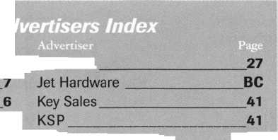

Legislative Updates

by Tim McMullen

NUMEROUS CONVENTION LEGISLATIVE ACTIVITIES

Find out what’s the latest happening in your state capitol. Fax or E-mail your state representative or senator about a certain bill. Let your Governor know exactly what you think about him/her. Get free popcorn. Come to the “Thank You!” reception if you’re a Legislative Action Network member. This is just some of what you can expect this year from the Government Affairs department at the ALOA ’99 Convention and Security Expo. Here are some of the highlights:

THURSDAY JULY 29,1999 THRU  
SATURDAY JULY 31,1999

GOVERNMENT AFFAIRS BOOTH AT SECURITY EXPO

Noon-5 pm (4 pm Saturday)

Once again, we’ll have the popcorn machine serving up fresh hot buttered popcorn, but now we’ve added activities that you can partic­ipate in as well! On site, we’ll have information on all bills and legis­lation in your state PLUS an internet connection and fax machine so you can contact your state legislator directly. THIS IS GRASS­ROOTS LOBBYING AT ITS FINEST! And for your efforts, you’ll get a free door prize as well. You’ll also be able to purchase (and the only place on the Exhibit floor to do so) an official ALOA ’99 Convention poster. So come on by!

SATURDAY JULY 31,1999

PRESIDENTIAL ROUNDTABLE ON CHAPTERS AND REGIONAL ASSOCIATIONS

2 pm-4 pm

This meeting will be a defining moment in ALOA’s distinguished history. President Dallas C. Brooks is bringing together for the first time, a blue-ribbon panel of ALOA chapter chairmen and representa­tives from regional and state locksmith associations all across the nation to discuss how these organizations can work together more closely, especially in the areas of education and legislation. Please note that this roundtable is designed primarily for the Chairman, President or representative from each organization. Notify the ALOA office if you would like to attend.

STATE OF THE STATES ROUNDTABLE

5:30 pm-6:30 pm

This meeting is designed as a forum for ALOA chapters and local/state regional locksmith associations to share information about the state of locksmithing in their region and a dynamic way to share ideas. Primarily for the Chairman, President and Legislative representative from each organization, all locksmiths are encouraged to participate. This is the perfect opportunity to learn about what’s going on in the industry across the nation.

40 | KeynotesJune 1999

LEGISLATIVE ACTION NETWORK THANK YOU! RECEPTION

6:45 pm-7:45 pm

As a way to say “thank you” for all your hard work, ALOA is throwing a party for all members of the Legislative Action Network (LAN). This by-invitation-only event will be the perfect way to celebrate the legislative victories the association has had this year.

OHIO LEGISLATIVE MEETING

7:45 pm-8:30 pm

For those interested in what’s happening in the Buckeye state, this meeting will focus primarily on outside legislation affecting the industry, and your response to it.

**LEGISLATIVE UPDATE**

All bills that saw movement between 04/16/99 and 05/14/1999-

ARIZONA H2493

AUTHOR: Gerard, et al

SUMMARY: Relates to locksmiths; relates to work orders; relates to information retention.

STATUS: 04/08/1999 In SENATE Committee of the

WHOLE: Passed.

04/08/1999 From SENATE Committee of the WHOLE. To third reading.

04/20/1999 In SENATE. Read third time. Failed to pass SENATE.

CONNECTICUT S112

AUTHOR: Gaffey

SUMMARY: Requires the licensing of locksmiths.

STATUS: 04/21/1999 To JOINT Committee on JUDICIARY.

04/28/1999 From JOINT Committee on JUDICIARY: Reported favorably.

05/12/1999 Reported out of Legislative Commissioner’s office.

IOWA H310 (Formally H203)

AUTHOR: Committee on State Government

SUMMARY: Provides for the mandatory licensure of alarm system

businesses by the department of public safety, and makes many of the provisions of Code chapter 80A, which applies to the licensing of private investigative agencies and security agents, applicable to an alarm system business.

STATUS: 04/30/1999 Placed on Senate Calendar for unfinished

business to be discussed when legislature reconvenes on

01/04/1999-



ILLINOIS H620

AUTHOR: Capparelli, Saviano

SUMMARY: Amends the Private Detective, Private Alarm, Private

Security, and Locksmith Act of 1993; law does not apply to, “a person employed as an armed security guard at a nuclear energy, storage, weapons or development site or facility regulated by the Nuclear Regulatory Commission.”

STATUS: 05/07/1999 In SENATE. Read third time. Passed SENATE.

05/07/1999 Passed Both Houses.

ILLINOIS S452

AUTHOR: Burzynski

SUMMARY: Amends the Private Detective,Private Alarm, Private

Security, and Locksmith Act of 1993; provides that an agency may employ a person under the act if the person possesses a valid permanent employee registration card or if the person has a valid license under the Act. An Amendment to the bill provides that police, fire or other municipal employees may open a lock in a life-threatening when the location of a vehicle creates a danger to the public, or when a diligent effort has been made to contact a licensed locksmith who can provide the service in a timely manner as determined by the police, fire, or other municipal employee, who shall take into consideration the health and safety of the occupants of the vehicle. Amend-ment also added that the Department may issue temporary cease and desist order for perceived violations of the act.

STATUS: 05/06/1999 In HOUSE. Read second time.

05/06/1999 In HOUSE. Placed on Calendar Order of Third Reading.

LOUISIANA H1860

AUTHOR: Durand

SUMMARY: Provides for various changes to the laws governing

locksmiths that are detrimental to locksmiths. Amendments soften the blow of the bill.

STATUS: 04/20/1999 Amended on HOUSE floor.

04/20/1999 Passed HOUSE. *****To SENATE.

04/22/1999 To SENATE Committee on COMMERCE AND CONSUMER PROTECTION.

05/13/1999 Committee amendment adopted on SENATE floor.

TEXAS S839 (Same as HI365)

AUTHOR: West

SUMMARY: Relates to security bars on residential dwellings.

STATUS: 04/19/1999 Passed SENATE. *****To HOUSE.

04/21/1999 To HOUSE Committee on PUBLIC SAFETY. 05/05/1999 From HOUSE Committee on PUBLIC SAFETY: Reported favorably.

05/11/1999 To CONFERENCE Committee.

For up-to-the-minute information on any of these bills,  
visit ALOA’s legislative update on the web at  
httpy/[www.aloa.org/news/legcom.cfm](http://www.aloa.org/news/legcom.cfm).



INTERCHANGEABLE  
CORE PRODUCTS

Interchangeable -glflmk, with:

* best 'TgslClJPy J|
* arrow mi,

•FALCON

Quality • Price *Delivery*

That's what KSP is all about!

KILLEEN SECURITY  
PRODUCTS

**Asfr** your wholesaler about  
our drop shipping**.**

CONTROL

***33 Hermon St.  
Worcester,*** Iff***A 01610  
Phone (508) 798-3200  
Fax (508) 753-2183***

WE’RE KEYED TO

YOUR NEEDS

Our brass key blanks are available in all  
popular numbers. Order 1000 - mixed or  
matched. Packed 50 to a box. $102 per  
1000 (Ford $14 per 100) F.O.B. Detroit.  
**Prices subject to change.**

INSTOCK:

Key Blanks Key Machines Locksmith Tools & Supplies Locks of All Types American & Foreign Automobile Locks Security Hardware (Wholesale Only)

AM1-41C-1041C  
AM3-J41-1046  
AR1-135-1179  
AR3-N1179A  
AR4-135A-1179A  
B1-98M-1098M  
B2-H98M-H1098M  
B5-98DB-1098DB  
BW-H98LA-H1098LA  
B11-098LA-01098LA  
B24-H98X-H1098X  
B44-X98E-P1098E  
B45-098H-S1098H  
B46-X98J-P1098J  
_B47-098K-S1098K  
B48-P91A-P1098A  
B49-S91B-S1098B  
B50-P91C-P1098C  
B51-S91D-S1098D  
B52/B4-98X-1098X  
_BE2-A114A-A1114A  
BN1-L54P-K1122D  
_B01/HL2-22B-R1003M  
CG1-41G-1041G  
CG2-41GA-1041GA  
~CG4/CG3-41GR-1041GR  
CG16-41R-1041T  
_CG17/KP1-41Y-1041Y  
CG22-41RB-1041E  
C01-20-1000  
C03-21EB-1001EB  
C07-21EN-1OO1EN  
'C010-20G-1000G  
C026-20V-1000V  
_C068-20VS-S1000V  
C087-22Z2-1001EH  
C088/C066-A22Z2-A1001EH  
'C089-A22GM-A1001ABM  
C091-A22A1-A1001AH  
C097-K22-1001GH  
C0106/HL1-R22B-1003M  
DE6-54DR-D1054K  
EA1-61-1014  
EA2TEA50-X61F-X1014F  
"EL10-C1096CN  
ER1-119-1119

ES8-1502  
FA1-F54-1054WC  
FR2-L54G-L1054G  
H26-127ES-1127ES  
'H27-127DP-1127DP  
H50S27-S1167FD  
H51-P27-1167FD  
"H54-PS23F3-1184FD  
H60-1190LN  
H03-170-1170B  
_HR1-X61FR-1014C  
IN1-54F-1054F  
IN3\ IN20-X54K-1054K  
IN8-L54B-L1054B  
1N18-X54F-X1054F  
JN28-54FN-1054FN  
“IN29-1054UN  
IN33-54MT-1054MT  
"IN35-1054DL  
_K2-79HK-1079B  
KW1-54KS-1176  
"LI-35-1004  
L4-35A-1004A

'MI-92-1092

M4-U92A-1092V _M10-92N-1092N M11-92T-1092H _M27/M16-92NR-1092NR NA12-174BN-1069LA 'NA24-1069LC ~NA25/NA6-N174D-R1064E NH1-N102-1177N RA3-99B-S1970AM RA4-99A-1970AM R01-62-1069 _R03-174J-1069N RU1-55-1011 RU4-55P101 IP RU16-57PA-A1011P _RU45-57-1D-1011D1 RU46-A57-1D-A1011D1 "SI-48-1009

JS3-50-1010 S4-050-1010U S6-049KM-N1007KMA S16-49KM-N1007KMB "S22-043LA-01007LA S221/2-43LA-1007LA S32-48KMR-N1007RMB

1. 51S-1010N
2. 51SA-L1010N SC1-145-1145 SC4-145A-1145A

‘SC6-307A-1307A SC7-145FS-1145F 'SC8-145ES-1145E SC9-145E-A1145E SC10-145F-A1145F SC20-145L-A1145L SC22-307W-1307W 'SE1-102-1022 SE8-102AB-1022AB SK1-R21EN-R1001EN 'T3-111E-1141E T7-111GE-1141GE WEI-133-1123 WK2-175W-1175N WR3-54WB-1054WB 'WR4-54WA-A1054WB WR5-54WC-N1054WB WR&FA2-F54A-A1054WC XL7-XL16-1180S Y1-14-999 Y1E-E14-999N Y2-14A-999A Y3-14YM-C999 'Y4-12GM-998 Y6-7X-997X Y11-7NX-01122 Y12-07NX-01122A "Y13-R7NX-01122R Y14-R07NX-01122AR Y52-7E-997E Y54-07E-0997E "Y103-07B-01122B Y149-S19-S1770U Y152-PI 9A-P1770U ‘Y220-X14S-999B

STOCKING DISTRIBUTORS FOR:

A-1 Security Mfg.

Abus Lock Co.

Alarm Lock All Lock Co.

American Lock Co.

Arrow Lock

Auto Security Products

B.E. Industries, Inc.

CCL Security Products Detex

Don-Jo Mfg. Co.

EMTEK

ESP Lock Corp.

Fort Lock Corp.

Framon Mfg. Co., Inc.

nro, me.

Hudson Lock Co.

ILCO Unican Corp.

Keedex

Keystone Novelty Co.

Key Systems KSP

Kwikset Hardware Group LAB

Lori Corp.

Lucky Line Products Corp. Mag. Engs. & Mfg. Co., Inc. Master Lock Morse Tools Multi Lock, Inc.

S. Parker Hardware Pro-Lok Co.

Quincy Mfg. Co. SchlageLockCo.

Silca

STF1ATTEC

Supra

Trans-Atlantic Co.

Trine Mfg. Co.

Wilson Bohannan Co.



Send in order or

request order  
form.



1-800-445-KEYS (5397)  
313-931-7720

Fax: 1-800-828-KEYS (5397)

Local Fax: 313-931-7758  
9950 Freeland  
Detroit, Michigan 48227

June 1999

Keynotes

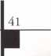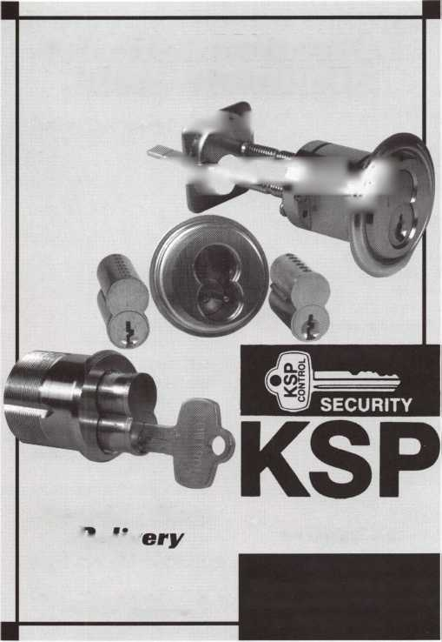

**Keynotes readers get the last word...**

Every year Keynotes awards the “Author of the Year” to the locksmithing scribe who has gone beyond the call of duty  
when writing and submitting articles to Keynotes. Since our readers are a vital part of the magazine’s success, we’ve  
decided to let this year’s award be decided by “Readers Choice!” As an added bonus, the first 20 ballots received this  
month will receive an ALOA ’99 WAY COOL! t-shirt!

Review the list of articles below from April ’98 to March ’99 and select your favorite author. Feel free to comment  
on what influenced your author selection; and the stories you found to be the most valuable, and why. Thank-you from  
Keynotes for your participation; and from our authors for your support and helpful feedback.

**1998**

**APRIL**

Low Tech Products

Sal Dulcamara, CML

Inside 3M

Steven Spiwak, CRL

A Conversation with Rovey

Paul Chandler

The Evolution of the Security Industry, Part III

Steven Spiwak, CRL

Servicing Mul-T-Lok Heavy Duty Padlocks

Sal Dulcamara, CML

Biometrics

Steven Spiwak, CRL

**MAY**

So You Can Do Safe Work Too?

James Jeffries

Impressioning Single Bitted GM Keys

Steven Spiwak, CRL

Promoting Your Business

Steven Spiwak, CRL

Reconstructive Surgery for Safes, Part I

Daniel Graffeo, CRL, CMS

The Ethics of “Do Not Duplicate”

Sal Dulcamara, CML

HPC’s In-A-Minute Auto Lock Decoder

Sal Dulcamara, CML

The Importance of Home Security

Steven Spiwak, CRL

**JUNE/JULY** Bi Lock

Steven Spiwak, CRL

A-l’s #J-50 Simplex 1000 Installation Jig

Sal Dulcamara, CML

InstaCode

Sal Dulcamara, CML

The Sliding Magnalock

Greg Perry, CML, CPS

Powerlever

Paul F. Chandler, CRL

Reconstructive Surgeiy for Safes, Part II

Daniel Graffeo, CRL, CML

**AUGUST** Key Master

Sal Dulcamara, CML

To Master Key or Not?

Jerome Andrews, CML

A Delicate Balance

Steven Spiwak, CRL

**SEPTEMBER**

Who Are the Crime Prevention Experts?

Sal Dulcamara, CML

Point/Counterpoint:Licensing

Sal Dulcamara, CML and Kathy Zaniolo, CPL

Unusual Locks, Unusual Methods

Sal Dulcamara, CML

The Role of the Professional Locksmith

Steven Spiwak, CRL

Behind the Scenes with ALOA Continuing Education

Paul Chandler, CRL

**OCTOBER** Auto Lock Tools

Sal Dulcamara, CML

AutoTel Tells All

Sal Dulcamara, CML

High-Tech Ignitions

Fred Kosloske

The Chrysler 8-Cut Kit

Sal Dulcamara, CML

The Other Automotive Customer

Buddy Logan

GM Progression 101

Steven Spiwak, CRL

**NOVEMBER**

Is There a Drill Doctor in the House?

Sal Dulcamara, CML

A Simple, But Effective Tool (to Solve a Major Problem)

Steven Spiwak, CRL

Specialty Screwdrivers from Keedex

Sal Dulcamara, CML

The Singertech Neutralizer Tool

Sal Dulcamara, CML

New Life for an Old Install

Greg Perry, CML, CPS

Reading the Fine Print of Responsibility in Limited Warranties

Paul F. Chandler, CRL

Customer Feedback

Claire Cohen, CML

**DECEMBER**

Schlage Enters the 1-Core Market

A. J. Hoffman, CML

Image Vault Digital Security

James H. Glazier, CML

Is There a Niche for You In the Booming CCTV Market?

Paul F. Chandler, CML

Introducing e.Primus

Paul F. Chandler, CML

Best Type Interchangeable Cores, Part I

Charles H. Cole, CML

**1999**

**JANUARY**

Titan Commercial Series Lever Handle Lock

Sal Dulcamara, CML

Hardware Restoration

Don Dennis, CPL

Schlage AL-Series Lever

Sal Dulcamara, CML

Best Type Interchangeable Cores, Part II

Charles H. Cole, CML

Mississippi Learning

Paul F. Chandler, CRL

Abus Diskus-Now Rekeyable

Sal Dulcamara, CML

The PRP. Oh, How You’ve Changed!

Claire Cohen, CML

The Shop Van, Part I

Michael Ferrill

**FEBRUARY**

Access Control with a Little Help from Ma Bell

Paul Chandler, CRL

Motorcycle Locksmithing: Suzuki

Ray D’adamo, CML and Tina D’adamo, CRL

Puttin’ on the Blitz

Sal Dulcamara, CML

1C Tools from PRO-LOK

Sal Dulcamara, CML

The Shop Van, Part II

Michael Ferrill

**MARCH**

Business Growth Requires Modem Software Solutions

Paul Chandler, CRL

Car Keys and Computers

Sal Dulcamara, CML

Magazine Cross Reference from Data Logic

Sal Dulcamara, CML

So, You Think You Want To Be A Small Town Locksmith?

C. D. Lipscomb, CML, CPS

The Locksmith Business Card

Michael Ferrill

Computer Shortcuts

Claire Cohen, CML

Please submit your vote with the following information by mail, fax or email to:

**Keynotes** Author of the Year, 3003 Live Oak Street, Dallas, TX 75204 fax: (214) 827-1810 • email: [keynotes@anet-dfw.com](mailto:keynotes@anet-dfw.com)

Name:

Member Number:

My selection for Author of the Year is:

I selected this author because:

My favorite story/stories and why:

«L

Keynotes

June 1999

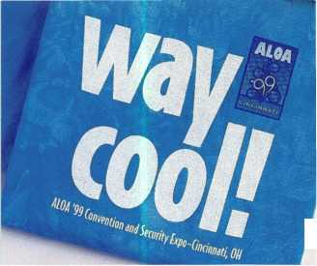

Keynotes

Authors



(Dept)

Jerome Andrews,

CML, is IDN’s sales and technical  
services representative for the state of  
Ohio. He is the author (/Funda-  
mentals of Master Keying and  
instructs a two day course entitled  
Master Keying Methods and Formats.

Donald B. Dennis, CPL has hem dealing with the Locksmithing profession since 1972 with a four year apprenticeship in Albuquerque, New Mexico. He founded and has hem the owner of Dennis Safe & Lock in Johnson City, Tmnessee since 1977. He was the founder of the East Tmnessee Locksmith Association in 1988 and is currmtly the Chairman of the Education Committee and editor ofETLA Newsletter.

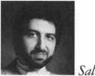

CML, has hem in the locksmith business for over 24 years. He is the presidmt of All Pro Security, Inc. in Michigan and has hem an ALOA member for 17 years. A past presidmt of the Locksmith Security Association of Michigan. Sal currmtly serves as editor of the association newsletter. He was named “Keynotes Author of the YeaP’ for 1996 and 1997 and is currmtly a Contributing Editor.

Poul Dyson is a contractor for IDN in Canada.

Bill Edwards is a locksmith by trade and is presmtly the Key Records Manager for Master Lock Co. in



Milwaukee. A recipimt of the Philadelphia Award, he has held the same position of Key Records Manager with five other lock companies as well and is a Co-Chairman of the LIST Council.



Editor of Keynotes and a freelance music, film, real estate and community evmts writer.

Mike Ferrill is a

third generation locksmith, who lives  
on the Island of Nantucket in  
Massachusetts.



Greg Perry, CML, CPS, has hem in the locksmith industry for 18 years. He's spmt half that time as a field technician for the Security Engineering in Ridgecrest, Calif. Greg’s also a past presidmt of Desert Counties Chapter of the California Locksmiths Association



Tim McMullm

oversees legislative affairs for ALOA.  
He is a graduate of the District of  
Columbia School of Law and has  
an extensive background in  
legislative work.

New Mexico Locksmiths Association  
1999 Annual Convention

August 5 8, 1999

P. 0. Box 30956 • Albuquerque, NM 87123 • (505)268-8663 • (505)435-9843

Classes in “Basic Electricity,” “Access Control,” “Safe Lock Servicing,” “Safe Penetration,” “Auto Lock Servicing”and “Interchangeable Core” are conducted by ALOA Continuous Education [ACE), instructors. A seminar in “Tricks of the Trade,” will be conducted by D. W. Dowless on Friday at 7 p.m. The trade show will be combined with a reception hosted by NMLA and the exhibitors. The 6th Annual Charity Golf Tournament will tee off at 9:00 a.m., Thursday, August 5th, at the Los Altos Golf Course. Thursday evening in the hospitality suite at the Ramada Mountainview Hotel, trophies will be awarded. The Awards Breakfast and Annual Membership Meeting will start at 8:00 a.m. Sunday morning and will be followed by the Proficiency Registration Program and the Safe Technician Certification Program. The Ramada Mountainview Hotel is located at 25 Hotel Circle NE, near 1-40 exit 165, at Eubank NE and Lomas NE in northeast Albuquerque.



June 1999

Keynotes

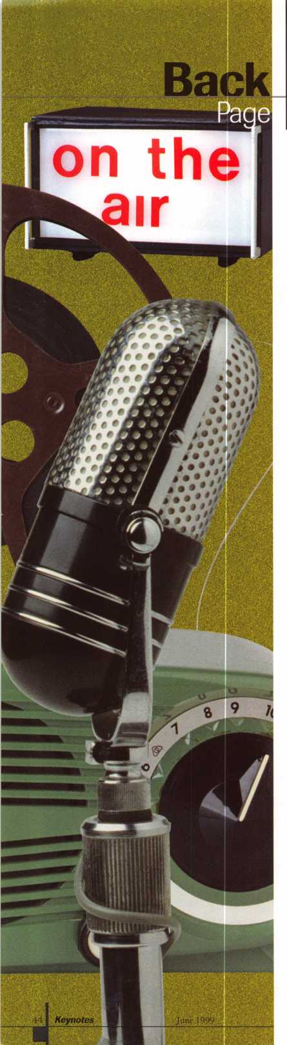

**WKRPin**

**Cincinnati**

When you think of Cincinnati, it’s hard not to recall the CBS sitcom, WKRP in  
Cincinnati (1978-82). The show, which detailed the daily workings of a radio station,  
appealed to viewers young and old because of its memorable characters, clever stories  
and hilarious scripts. With that, here’s a WKRP quiz for all of you trivia buffs. Send  
your correct answers to the address or fax number listed below. Well draw a winner  
who will be awarded a special prize courtesy of ALOA!

1. Name the fictional English band who had an altercation with the station’s DJs.
2. Howard Hessman played the mellow DJ named Doctor Johnny?
3. WKRP once played easy listening music.

What kind of music made the station popular?

1. One of Burt Reynolds’ many ex-loves played the station’s sultry secretary.

Name the actress.

5 Tim Reid later went on to star in Simon and Simon and Sister, Sister. Name the funky  
DJ he portrayed. (Hint: He was named after an insect-eating plant.)

Send your answers to:

**Keynoted** WKRP Quiz

3003 Live Oak  
Dallas, TX 75204  
or fax to: 214.827.1810

Q extend my subscription to Locksmith Ledger International

Please

l A

| 13 YEARS (includes 36 issues, 3 FREE Annual Directory* issues)

USA $90.00

J 2 YEARS (includes 24 issues, 2 FREE Annual Directory* issues)

USA $64.00 Canada $93.00 International (air) $185.00 International (surface) $119.00

J 1 YEAR (includes 12 issues, 1 FREE Annual Directory* issue)

USA $41.00 Canada $52.00 International (air) $100.00 International (surface) $65.00

’Comprehensive guide to industry manufacturers, distributors, products and services.

**CARD INVALID UNLESS COMPLETE DATA IS GIVEN**

You must indicate your locksmithing affiliation below:

1. Are you a locksmith or an individual involved in locksmithing? **Qyes Qno**
2. Your position is: Qowner/Pres. Q3 Employee Q6 Student Q9 Other (specify)

3 Business classification (check one only): a Q Locksmith Shop b □ Hardware c □ Wholesaler/Distributor d Q Manufacturer e Q Security or Maintenance

1Q Consultant 3 Q Industrial 5Q Government

2 Q Commercial 4 Q Institutional 6 Q Police g Q Architect/Specifier z Q Other (specify)

4. Are you involved in purchasing or influencing the purchase of locksmith products?

**□ yes Qno**

Name:_

Company:, Address: _

City:,

State:,

_Zip:_

Phone: _

_Fax:.

Payment (US FUNDS ONLY): □Money order □Charge Card □Check#:

Complete For Charge Orders Only: QVISA □ Master Card □American Express

Account # :Exp. Date:

Signature:

IM9

Send payment to: Locksmith Publishing Corp. • 850BusseHwy. • Park Ridge, IL 60068 • Phone:(847)692-5940 • Fax (847) 692-4604 • Website: [www.lpc.simon-net.com](http://www.lpc.simon-net.com)

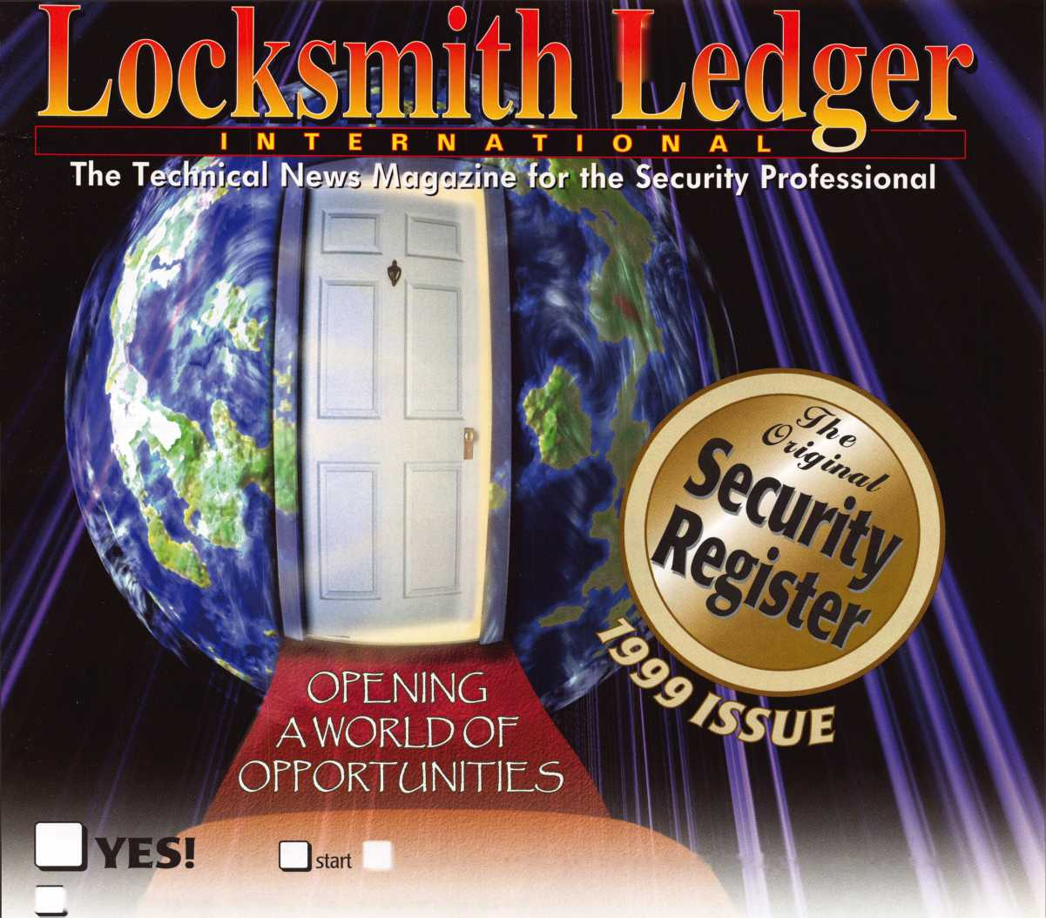

**Locksmiths...**

**duplicat**

e

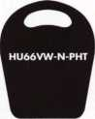

HU66YW-NPHT

Audi

Porsche

Volkswagen



**GM97-N-PHT**

Buick Park Avenue Chevy Venture Olds Silhouette Pontiac Montana Primary

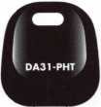

For Windows 95/98

Now you can duplicate electronic transponder keys without your customer bringing in  
their car or the original key. Store the codes in your database for future use.

It’s convenient, fast and profitable.

It’s another JET innovation.

JET ETD - DUPLICATOR software for Windows 95/98 is conveniently provided on CD-ROM

JET HARDWARE MANUFACTURING CORP

800 HINSDALE STREET, BROOKLYN, NY

MAZ24-N-PHT

Mazda

Nissan Maxima

Infiniti 130

**or**

